**Improving Linde’s corporate IT Demand Process through Business Capability Management?**

**Analysis of the core capability “Deliver Product”**

BACHELOR THESIS

submitted on 20.04.2023

|  |  |
| --- | --- |
| Faculty: | Economy |
| Branch of study: | Wirtschaftsinformatik - IMBIT |
| Academic year: | 2020 |
| Semester: | 5th Semester |
| Course: | WIMBIT20B |

from

**Stefan Kuchenbauer (8885219)**

|  |  |
| --- | --- |
| Linde plc | Baden-Württemberg Cooperative State University Mannheim |
| Tobias Hust | Prof. Thomas Schuster |

Confidentiality Statement

The diploma thesis on hand

“[topic]”

contains internal resp. confidential data of Linde plc, Dublin. The content of this work may not be made accessible to people outside of the testing process and the evaluation process neither as a whole nor as excerpts, unless an authorisation stating otherwise is presented by the training facility.

Abstract

Lorem Ipsum Lorem Ipsum Lorem Ipsum Lorem Ipsum Lorem Ipsum Lorem Ipsum Lorem Ipsum Lorem Ipsum Lorem Ipsum Lorem Ipsum Lorem Ipsum Lorem Ipsum Lorem Ipsum Lorem Ipsum Lorem Ipsum Lorem Ipsum Lorem Ipsum Lorem Ipsum Lorem Ipsum Lorem Ipsum Lorem Ipsum Lorem Ipsum Lorem Ipsum Lorem Ipsum Lorem Ipsum Lorem Ipsum Lorem Ipsum Lorem Ipsum Lorem Ipsum Lorem Ipsum Lorem Ipsum Lorem Ipsum Lorem Ipsum Lorem Ipsum Lorem Ipsum Lorem Ipsum Lorem Ipsum Lorem Ipsum Lorem Ipsum Lorem Ipsum Lorem Ipsum Lorem Ipsum Lorem Ipsum Lorem Ipsum Lorem Ipsum Lorem Ipsum Lorem Ipsum Lorem Ipsum Lorem Ipsum Lorem Ipsum Lorem Ipsum Lorem Ipsum Lorem Ipsum Lorem Ipsum Lorem Ipsum Lorem Ipsum Lorem Ipsum Lorem Ipsum Lorem Ipsum Lorem Ipsum Lorem Ipsum Lorem Ipsum Lorem Ipsum Lorem Ipsum Lorem Ipsum Lorem Ipsum Lorem Ipsum Lorem Ipsum Lorem Ipsum Lorem Ipsum Lorem Ipsum Lorem Ipsum Lorem Ipsum Lorem Ipsum Lorem Ipsum Lorem Ipsum Lorem Ipsum Lorem Ipsum

Table of Contents

Table of Figures 4

List of Tables 5

List of Abbreviations 6

1 Introduction 7

2 Corporate Governance and IT Governance 9

3 Enterprise Architecture Management 12

3.1 Definition of Enterprise Architecture 12

3.2 Enterprise Architecture Viewpoints 13

3.3 Enterprise Architecture Frameworks 16

3.3.1 The Open Group Architecture Framework 16

3.3.2 Further Frameworks 23

3.4 IT Demand Management 25

4 Business Capability Management 27

4.1 Definition of a Business Capability and its elements 27

4.2 Business Capability Mapping 29

4.3 TOGAF artefacts to analyse Business Capabilities 31

5 Corporate IT demand management at Linde plc 34

6 Business Capability Management at Linde plc 41

6.1 Business Capability Map 41

6.2 Business Capability analysis across international regions 44

6.2.1 Business Capability “Deliver Product” 45

6.2.2 Execution of Deliver Product in Korea 47

6.2.3 Execution of Deliver Product in Germany 59

6.2.4 Comparison of Korea and Germany and its emerging hypotheses 70

7 Improving Linde’s corporate IT demand process through Business Capability Management 77

8 Recommendation 79

9 Summary 80

Bibliography 1

# 

# Table of Figures

Figure 1: Methodological approach (own illustration) 8

Figure 2: Interplay between business and IT through Enterprise Architecture (Own illustration based on (Aziz et al. 2005, p. 2) and (Kröschel 2015, p. 175)) 13

Figure 3: Enterprise Architecture categories (own illustration based on (Schwarzer 2009, p. 26)) 14

Figure 4: Enterprise Architecture layers (own illustration inspired by (Daud and Latief 2020, p. 458) and (Modelio 2023, p. 3)) 16

Figure 5: The covered sections of the TOGAF Standard in this thesis (own illustration based on (The Open Group 2022a, p. 8)) 17

Figure 6: TOGAF Architecture Development Cycle (The Open Group 2022h, p. 6) 18

Figure 7: Elements of defining a business capability (own illustration) 29

Figure 8: Excerpt from the Global Portfolio System showing the different demand management areas (Linde plc 2023c, p. 1) 35

Figure 9: Stages of the STEPS methodology (Linde plc 2023b, p. 6) 37

Figure 10: Corporate IT demand process (Linde plc 2023b, p. 15) 40

Figure 11: Extract from the business capability reference number list for the application inventory (Linde plc 2021a, p. 1) 44

Figure 12: Linde's largest gas business segments (own illustration) 45

Figure 13: Linde's standard gas cylinders in different shapes and sizes (Linde plc 2021e, p. 48) 46

Figure 14: Process flow diagram - PGP Korea (own illustration) 49

Figure 15: Information map with data entities and business functions - PGP Korea (own illustration) 55

Figure 16: Application landscape diagram - PGP Korea 56

Figure 17: Process flow diagram - PGP Germany (SG) (own illustration) 60

Figure 18: Process flow diagram - PGP Germany (IG) (own illustration) 63

Figure 19: Information map with data entities and business functions - PGP Germany (own illustration) 67

Figure 20: Application landscape diagram - PGP Germany (own illustration) 68

# List of Tables

Table 1: Required information for a demand request in the Global Portfolio System 38

Table 2: General information about PGP Korea 47

Table 3: Process / Event / Product catalogue - PGP Korea 50

Table 4: RACI matrix - PGP Korea 51

Table 5: Technology portfolio catalogue - PGP Korea 57

Table 6: Contract measure catalogue - PGP Korea 58

Table 7: General information about PGP Germany 59

Table 8: Process / Event / Product catalogue - PGP Germany (SG) 62

Table 9: Process / Event / Product catalogue - PGP Germany (IG) 64

Table 10: RACI matrix - PGP Germany 65

Table 11: Technology portfolio catalogue - PGP Germany 69

Table 12: Contract measure catalogue - PGP Germany 69

# List of Abbreviations

ADM *Architecture Development Method*

ASU *Air-Separation Unit*

BC *Business Capability*

capex *Capital Expenditures*

CObIT *Control Objectives for Information and Related Technology*

CRM *Customer Relationship Management*

Cyl *Cylinder*

DoDAF Department of Defense Architecture Framework

EA *Enterprise Architecture*

ERP *Enterprise Resource Planning*

FTE Full-Time Employees

GPS Global Portfolio System

IT *Information Technology*

IT-DM IT Demand Management

ITIL *Information Technology Infrastructure Library*

MODAF Ministry of Defence Architecture Framework

NAF *NATO Architecture Framework*

NATO *North Atlantic Treaty Organization*

OECD *Organisation for Economic Co-Operation and Development*

PMI *Project Management Institute*

RQ *Research Question*

STEPS *Standards & Tools for Project Success*

TOGAF *The Open Group Architecture Framework*

# 1 Introduction

In an industrial company such as the global gas and engineering company Linde plc (Linde plc 2023d, p. 1), information technology (IT) is characterised as a support function. The core purpose of IT is to support Linde's business in the best possible way. Although IT does not directly serve to create value, they have an impact on customer satisfaction and the success of the company (Eurostat 2013, pp. 3). To efficiently align business and IT as well as their strategies and objectives, the concept of Enterprise Architecture (EA) is applied (Widjaja 2020, pp. 2). The industry standard, The Open Group Architecture Framework (TOGAF) recommends the use of business capabilities (BC). BC describe the individual core capabilities of a company and outlines what is done there (The Open Group 2022k, p. 7). Through the BC model, business and IT can communicate on a jointly defined basis. This helps IT departments to better understand the core business and to support and drive IT accordingly (LeanIX GmbH 2023a, p. 3). An analysis of the specific BC "Deliver Product" in an international comparison between Germany and Korea will be carried out in the course of the work. This should clarify whether BC management can support Linde and specifically improve Linde's corporate IT demand process which is a mediator process between the business and IT.

Derived from this are the following research questions (RQ):

* RQ1: How can a BC be analysed across international regions?
* RQ2: What are differences and commonalities in the execution of the core capability "Deliver Product" in Korea and Germany?
* RQ3: Can Linde's corporate IT demand process be improved through BC mana-gement?

Other questions which may arise is

* how Enterprise Architecture benefits the business?
* whether BC management should be rolled out to other activities?

The aim of this Bachelor Thesis is to answer the listed questions in the further stages of this work. The following methodological approach used for the writing is presented in figure xy.

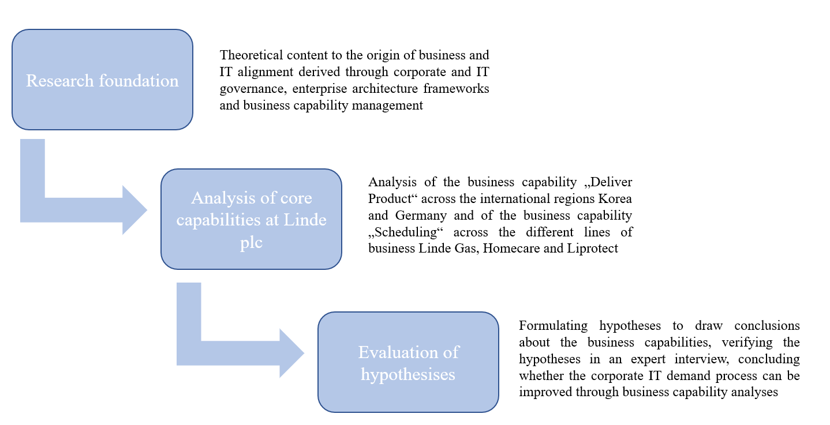

Figure 1: Methodological approach (own illustration)

To be able to answer the research questions, a scientifically researched foundation is necessary. Chapter 2 introduces corporate and IT governance as the overarching origin of business and IT alignment. In chapter 3, enterprise architecture is explained, and frameworks are presented. A special focus is placed on TOGAF, from which BC Management is also derived in chapter 4. This included accessing the DHBW Library Print and Digital Collection as well as online databases such as Google Scholar, Business Source Premier, SpringerLink, IEEE Xplore and more.

In the second part of the thesis, the topic is applied in the practical part using the example of Linde plc. Chapter 5 begins with the introduction of the current corporate IT demand process in the company. This is to be improved with the help of BC management. In order to find out the possibilities of BC, a BC analysis is performed. In the analysis, the four TOGAF components of process, roles, information, and resources are examined using the example of "Deliver Product". Korea and Germany are used as reference countries in a cross-national comparison.

Based on the analyses, an attempt is made to draw conclusions about BC analysis by formulating hypotheses. The hypotheses are verified and therefore are confirmed or disapproved in an interview with two experts at Linde. From this, it is deduced whether the BC analysis is a feasible and sufficient tool that could improve the corporate IT demand process at Linde and whether BC activities should be rolled out within the company.

# 2 Corporate Governance and IT Governance

The starting point for all IT-related decisions is corporate governance. Corporate governance is to be understood as self-set, but also externally dictated ethnic values, principles, procedures and measures for responsible corporate management. They apply to all internal and external participants involved in the company’s activities and are focused on the determination of the corporate goals, the identification of the ways and means of achieving them. (Tiemeyer 2023, pp. 3)

In Germany, for example, help in implementing corporate governance is provided by the German Corporate Governance Code introduced by the Federal Ministry of Justice in the early two-thousands. In addition to legal regulations directed towards German publicly listed companies, it contains internationally and nationally recognised standards of good and responsible corporate governance. (Bundesministerium der Justiz 2002) The counterpart to this at European level is the European Corporate Governance Forum (European Commission 3/6/2006). More specifically, the Organisation for Economic Co-Operation and Development (OECD) provides guidance through the publication of non-binding principles of corporate governance. They are intended to facilitate the interaction between management, supervisory board, shareholders and other stakeholders. Furthermore, they support the identification of ways and means to set and implement corporate objectives. (OECD 2015, pp. 9)

A narrow definition of corporate governance is provided by Mayer who defines it as “ways of bringing the interests and objectives of investors and managers into line and ensuring that firms are run for the benefit of investors” (2003, p. 83). It can be deduced from this that ownership (investors) and control (managers) should be distinguished and that managers should act in the best interests of the shareholders or owners of the company (Habisch et al. 2008, p. 73).

Specifically, the stakeholders addressed can be divided into three groups:

* Executive Board, Supervisory Board and Shareholders

The central position within the company as well as their rights and obligations of this group result from various stock corporation acts. A functioning interaction between the board of directors, the supervisory board and the shareholders is relevant both to ensure the company's ability to operate and to comply with laws such as the German Corporate Governance Code.

* Other internal stakeholders

A company’s governance model defines the roles and responsibilities, the processes, authority directives and policies of other stakeholders within the company, such as divisions, functions and organisational units.

* Stakeholders outside the company

The relevance of stakeholders who are outside the company, e.g. media, competitors and public institutions, is highly dependent on the company in particular. Due to the individuality of the factors influencing corporate governance, it receives only limited attention in literature and standards such as the Corporate Governance Code.

All groups of stakeholders have varying interests. Thus, a multitude of different influencing factors have an effect on corporate governance, which it translates into rules and guidelines that are applied within the company. (Rüter et al. 2010, pp. 1–4) Corporate executives are therefore provided with a framework for the introduction and execution of planning, decision-making, evaluation, controlling and monitoring tasks. This enables a solution-oriented contribution to corporate success in terms of sustainable value creation. All these elements - if well-defined and coordinated - contribute to the seamless interaction of the organisational units and offer concrete recommendations for action. (Tiemeyer 2023, p. 3)

In addition, these rules and guidelines include technological aspects, especially with regard to IT, which must be taken into account within the framework of IT governance. Due to the interconnectedness of business and IT, IT governance is a central component of corporate governance. These two aspects cannot be considered separately from each other, as the strategic orientation of IT and corporate goals are equally relevant for the success of the company (Meyer et al. 2003, p. 446). Furthermore, all business processes are connected to IT and depend significantly on its support. The use of IT therefore generates corporate value and entails risks. IT governance manages the risks, directs all IT efforts and measures their performance (IT Governance Institute 2003, p. 13). Corresponding IT governance frameworks for IT management are provided by Control Objectives for Information and Related Technology (CObIT) and Information Technology Infrastructure Library (ITIL) (Fröhlich 2007, pp. 17). ITIL offers a structured approach to IT governance and management that assists companies in efficiently managing IT services (Gërvalla et al. 2018, pp. 181).

In the CObIT framework, IT Governance is defined as “a structure of relationships and processes to direct and control the enterprise in order to achieve the enterprise’s goals by adding value while balancing risk versus return over IT and its processes.” (IT Governance Institute 2000, p. 3) Furthermore, according to the Gartner glossary, IT Governance is defined “as the processes that ensure the effective and efficient use of IT in enabling an organization to achieve its goals” (Gartner n.d.). This means that principles, procedures, and policies are designed to ensure that IT is used to fulfil business objectives, responsibly deploy resources, and appropriately monitor risks (Rüter et al. 2010, pp. 20).

The overarching task is to translate and mediate between corporate management, business areas and IT departments. However, typical tasks of IT governance can be divided into two types: operational and strategic. Selected examples of operational tasks that are carried out in the daily IT routine are, among others, the management and administration of hardware assets and software licences, compliance, risk and security management, IT purchasing and IT controlling, IT service, IT project management and IT process management. On the other hand, there are the strategic governance tasks such as IT demand management and IT architecture management. Both ensure that the corporate goals and the strategies of the business areas derived from them are aligned with the IT strategy. (Helmke and Uebel 2016, pp. 27–29) Several corporate goals can be achieved through these tasks. These include, for instance, aligning IT with the needs of the business and realising the promised benefits, which increases the value of the business as well as maximising the benefits from IT. Furthermore, IT resources are used responsibly and risks can be identified and anticipated at an early stage. (IT Governance Institute 2003, p. 13) The focus of this thesis is placed on the strategic side of the IT governance.

# 3 Enterprise Architecture Management

A fundamental precondition for successful decision-making through strategic IT governance is comprehensive and holistic view of the organization's IT processes, assets and capabilities. This is achieved through EA management, which will be investigated in the following chapter. (Bartenschlager and Goeken 2010, p. 1)

## 3.1 Definition of Enterprise Architecture

The expression EA consist of two words parts. The latter, “architecture”, is used analogously to the architecture of the building construction as a term for the model-like representation of a system structure. By referencing the enterprise, the focus of the architecture is placed on the fundamental structure of the organisation. (Wissotzki 2018, p. 41) The origin of EA dates back to the 1980s, when Zachman developed a framework for describing and structuring IT elements (1987, pp. 284–286). Since then, the number of scientific publications on the topic has increased steadily (Buckl and Schweda 2011, pp. 1). Finding a generally recognised and commonly used definition is difficult due to the large number of different concepts (Stelzer 2010, pp. 9–11).

Following Grant’s and Collins’ definition, EA is the coordination of the “relationship[s] between business imperatives, business processes, information flows, information systems applications, and the technology and physical infrastructures that support the business in achieving its strategic objective” (2016, p. 98). What is outstanding here is the holistic approach that EA has on the organisation. Although it deals with typical IT domains such as information flows, software applications and infrastructure, it also includes the business in equal shares. The goal is to harmonise IT and business in such way that the business strategy, which is derived from corporate governance, can be supported in the most optimal way in order to achieve the company's goals. The interplay between business and IT is illustrated in figure 2. When this is happening, it is also described as a business-IT alignment. (Reinheimer and Robra-Bissantz 2017, p. 8)

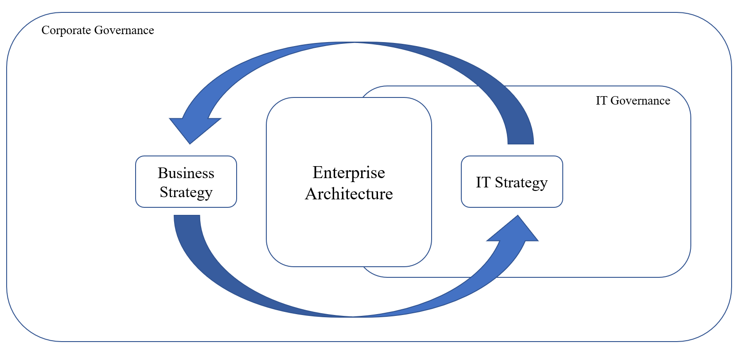

Figure 2: Interplay between business and IT through Enterprise Architecture (Own illustration based on (Aziz et al. 2005, p. 2) and (Kröschel 2015, p. 175))

An all-encompassing architecture is essential for the achievement of this goal. Without, it is still possible that individual local areas in the company already operate in a fully optimised way. However, it is only effective for the company as a whole if all areas are coordinated with each other. That is why the EA tries to capture the most essential aspects of business and IT. The idea is that the essentials are long-lasting and should therefore be preserved, while remaining flexible in the company's orientation and being adaptable. A good architecture manages to balance these conditions and facilitates the implementation of the corporate strategy in everyday operations. It is therefore inevitable for a successful business.

The basic requirement for a high architectural quality is an approach that can be understood by all parties involved in the company. While a common language for the general public already exists in building architecture since thousands of years, it is yet to be developed within daily business vocabulary. An important challenge of EA is to establish a common frame of reference that includes the entire company. (Lankhorst 2013, pp. 3)

## 3.2 Enterprise Architecture Viewpoints

The goal of EA is to align the enterprise with the corporate strategy and the business requirements derived from it (Simon et al. 2014, pp. 6). The main activities can thus be divided into three categories which are listed below and highlighted in figure 3.

Category 1 – Assess

In the beginning, it is required to understand the current status quo of the organisation's existing architecture. This can be used to evaluate how the prevailing state is in line with the strategy. In addition, potential deficiencies and risks in the architecture can be identified. The result of this analysis is also called as-is or baseline architecture. It serves as the basis for the planned redesign of the enterprise.

Category 2 – Aim

In the next phase, a proposed future architecture is worked out. Here, the identified deficiencies are addressed and appropriate solutions to the weaknesses are articulated. This is referred to as the to-be or target architecture. It forms a guideline for changes to the current organisation in order to steer it in the desired direction.

Category 3 – Act

The transformation process begins in the Act phase, with the realisation and implementation of the target architecture. The underlying architecture continues to serve as an access point and source of information and is the reference point for measuring progress and identifying necessary adjustments to the transformation project.

These tasks are recurring activities and no one-time events. The company needs to continuously look at market developments and business objectives to review and update the assess, aim and act phases accordingly. (Greefhorst and Proper 2011, pp. 21)

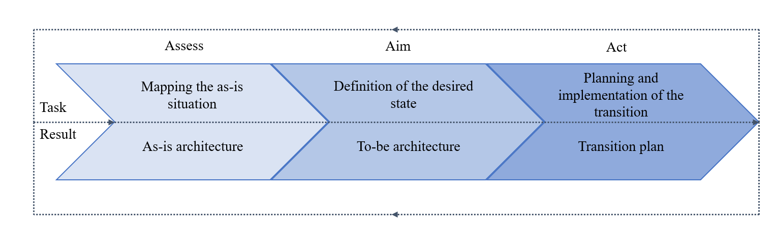

Figure 3: Enterprise Architecture categories (own illustration based on (Schwarzer 2009, p. 26))

In the realisation of transformation projects, EA serves the role of a mediator between the two perspectives of business and IT on the way to fulfil the corporate strategy (Wissotzki 2018, pp. 55). The two perspectives are reflected by four architectural layers that represent different viewpoints on the overall architecture. Figure 4 illustrates the role of enterprise architecture for coordinating business and IT based on the following four architectural layers.

Layer 1 – Business architecture

The business architecture layer represents the business model, the derived corporate strategy and its goals as well as the implementation through business processes, BC and the organisational structure of the company.

Layer 2 – Data architecture

The IT perspective is represented through the three other layers. Data architecture defines what kind of information and how data is recorded, structured, stored, processed and used.

Layer 3 – Application architecture

At the application architecture level, it is determined which application systems are deployed to support the processes inside the company. The interactions and relationships between applications are core of this consideration.

Layer 4 - Technology architecture:

The underlying technological infrastructure that enables the use of applications and the handling of data is part of the technology architecture. It includes hardware, software, network, security, communications and cloud computing architectures. (Barroero et al. 2010, p. 33)

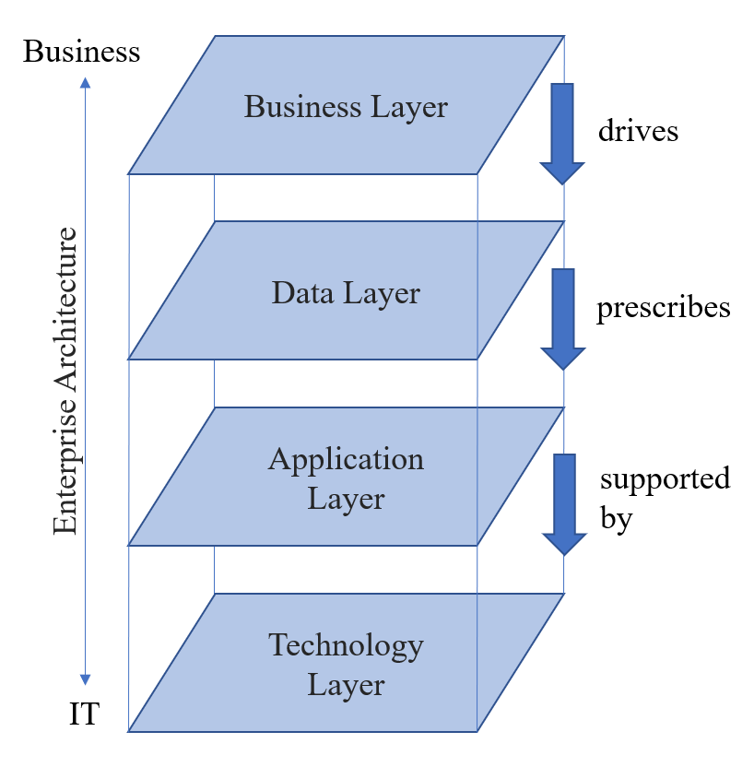

Figure 4: Enterprise Architecture layers (own illustration inspired by (Daud and Latief 2020, p. 458) and (Modelio 2023, p. 3))

A more in-depth examination of the architecture layers is provided in chapter 3.3.1 in the description of EA frameworks.

## 3.3 Enterprise Architecture Frameworks

EA frameworks have been developed to provide enterprise architects with a structured and systematic method for designing views and models to the different layers mentioned before. These frameworks allow architects to map and describe all kinds of information on an abstract level. This enables a unified and consistent representation of architectural solutions that facilitates effective communication between different stakeholders in the organisation. The orientation towards frameworks offers architects an efficient way of working. At the same time, they can ensure that their work conforms to company-wide standards and best practices. (Op ’t Land et al. 2009, p. 39)

Overall, there are several EA frameworks that are widely used and provide guidance in aligning basic business goals and strategies with technical requirements (Dumitriu and Popescu 2020, p. 938). A few selected ones are examined below.

## 3.3.1 The Open Group Architecture Framework

The most commonly used framework in practice is TOGAF, published by The Open Group (Simon et al. 2013, p. 4). Over 900 organisations, companies, consultants, academics and researchers have collaborated for this work (The Open Group 2018, pp. 1). This explains, why it is also considered as the unofficial standard for EA as a whole, which is the reason why it is presented in more detail (Op ’t Land et al. 2009, p. 72).

In 1995, TOGAF was first released on the basis of an architecture framework of the US Department of Defense with a primary focus on IT architecture (Buckl and Schweda 2011, p. 50). Today, the 10th edition of the TOGAF Standard is more comprehensive, promising that the best practices delivered are applicable to all industries and support the development, maintenance and use of any type of EA (The Open Group 2022b, p. 5). It contains the entire spectrum of knowledge necessary for successful EA implementation, which is structured in two parts presented in figure 5. The documentation is divided into TOGAF Fundamental Content and TOGAF Series Guides. The former provides the framework in the form of core concepts of the EA and will be explained in the following. The latter supports its configuration and therefore is not mentioned any further in this thesis.

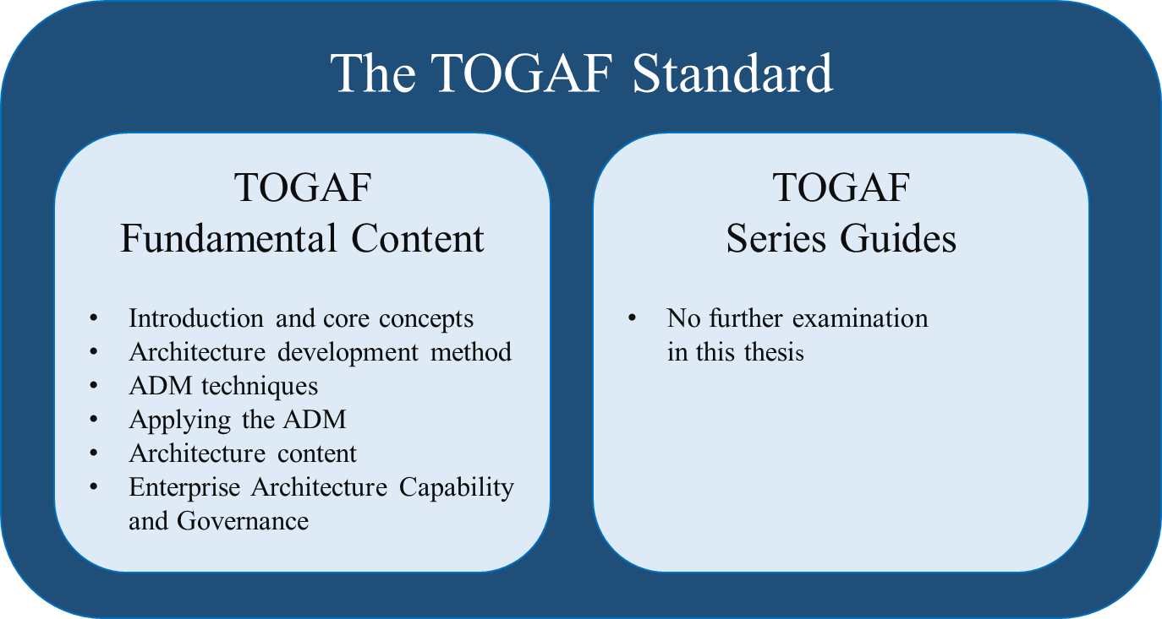

Figure 5: The covered sections of the TOGAF Standard in this thesis (own illustration based on (The Open Group 2022a, p. 8))

The TOGAF Fundamental Content consists of six parts (The Open Group 2022c, pp. 2).

Part 1 - Introduction and core concepts

The first part provides a general introduction to the key concepts of the TOGAF approach and definitions of the terms used. Furthermore, the main reasons why a comprehensive EA is needed are explained. From TOGAF's point of view, the processes, which often are fragmented are integrated into an optimised common environment that can react flexibly to changes and supports a targeted implementation of the corporate strategy. Information is used effectively so that a digital transformation in the company can succeed without losing operational efficiency. A holistic approach can create synergies between the individual business units. Last but not least, global data protection laws also require that, for example, processes in which personal data are processed or stored are documented in a way that can be understood by untrained readers. (The Open Group 2022j, pp. 4–6)

Part 2 - Architecture Development Method

The Architecture Development Method (ADM) is seen as the core of the framework. Here, the procedure for the development of a new EA or the adaption of an existing EA and its life cycle is explained in nine phases which are presented in figure 6, TOGAF's visual identification mark. Each phase is a detailed step-by-step process for identifying the key activities required to acquire the knowledge needed to develop an EA. For the enterprise architect, it provides a clear sequence of operations that help to maximise efficiency and productivity.

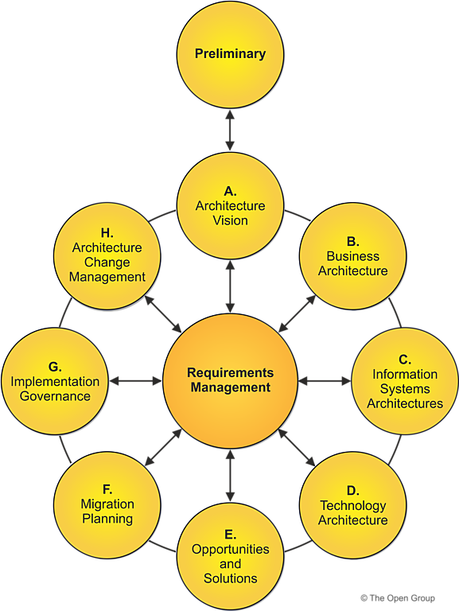

Figure : TOGAF Architecture Development Cycle (The Open Group 2022h, p. 6)

Each of the nine phases Preliminary and A to H are further subdivided into steps, which are explained in the following. In the following, the phases of ADM are introduced.

Preliminary Phase: In the preliminary phase, the architectural capabilities required by the organisation are determined. The key stakeholders are identified and the goals of the architecture project are defined. In addition, the processes for proceeding with the development and maintenance of the architecture are specified. As this phase lays the necessary groundwork for further work, it is crucial for the ongoing success of the enterprise architecture. (The Open Group 2022x, pp. 4–7)

Phase A - Architecture Vision: In the first phase of the ADM circle, the architecture vision is developed. The vision provides a high-level view of the desired EA and serves as an orientation guide for the development. The enterprise architects team works closely with relevant stakeholders in the organisation to identify business drivers, objectives and also constraints that have impact on the EA. The outcome of this phase is a clear image of the target architecture from which an architecture development roadmap can be derived, as well as a determination of the business value that can be realised. (The Open Group 2022n, pp. 4–8)

Phase B - Business Architecture: Phase B corresponds to layer 1 mentioned in chapter 3.2. The focus of phase B is on developing a target business architecture. This defines the business side of the EA, such as BC, organisational structure and processes to achieve the previously elaborated architectural vision. A gap analysis between the baseline and the target architecture is then performed. The knowledge gained from this is the prerequisite and basis for the work of the data, application and technology architecture in phases C and D which represent the other layers introduced in chapter 3.2. (The Open Group 2022o, pp. 4–8)

Phase C - Information Systems Architecture (Data Architecture and Application Architecture): In phase C, the target information system architectures are created, in a form in which the business architecture can ideally be put into practice. In order to do justice to the information systems to be deployed, TOGAF has split the phase into two sub-phases, data architecture and application architecture. (The Open Group 2022p, p. 4) The purpose is to find out what kind of data is processed and stored and which applications are involved. Then the existing information systems are evaluated in terms of their performance and suitability for supporting the target architecture. Similar to phase B, a gap analysis is used to identify gaps between the as-is and to-be architecture. Based on its findings, a plan is developed to address the gaps and integrate the information architecture with the other architecture domains. This includes, for example, new requests for applications, data, and interfaces. (The Open Group 2022r, pp. 3–9) (The Open Group 2022q, pp. 3–5) Because of their scope, data and application are separated in TOGAF, however, they must be viewed jointly (The Open Group 2022p, p. 3).

Phase D - Technology Architecture: Phase D is similar to the previous two phases. The core of the phase is the technology components required to deliver the information systems and related services. Here, after completion of the gap analysis, following the procedure of phase B and C, a target technology architecture plan is developed that includes specifications for the required hardware and network infrastructure. (The Open Group 2022s, pp. 3)

Phase E - Opportunities and Solutions: As the name implies, phase E attempts to deliver a specific solution for implementing the target architecture. The input used here from phases B, C and D such as requirements and architecture documentation are refined again. By combining the gap analyses and recommendation from the previous phases, a first complete version of the architecture roadmap is generated. Often the change actions are so large that an incremental approach must be executed, consisting of intermediate or transitional architectures. Thereby, individual work packages are arranged in a timeline to reach the target architecture. (The Open Group 2022t, pp. 4–6)

Phase F - Migration Planning: The early stages of ADM identify the need for architectural changes, after which a roadmap for the target architecture is developed. In stage F, a migration plan is created that describes the steps required to transition from the as-is architecture to the to-be architecture. An essential element of this phase is the clarification of the business value for the stakeholders in the organisation. In collaboration with them, the costs of each work package are first calculated and then prioritised using criteria such as performance improvement, return on investment, business value, effectiveness measurements and strategic fit. (The Open Group 2022u, pp. 4–7)

Phase G - Implementation Governance: The actual implementation of the architecture takes place during phase G. Each iterative transformation represents a step towards the target enterprise and fulfils the business interests. The main task of the enterprise architects is to oversee the implementations and to constantly check that the ongoing projects are in line with the predefined architecture. This manifests itself in the definition and establishment of governance structures, procedures for monitoring and reporting progress, and methods for making changes to the architecture as needed to ensure that the architecture remains consistent with the goals of the enterprise. (The Open Group 2022v, pp. 4–7)

Phase H - Architecture Change Management: During the iterations, the need for changes to the requirements and the architecture plan is detected regularly. Phase H describes the change management process that addresses and manages the proposed changes. This demands continuous monitoring of the requirements using the measurements created in phase G, but also of new technologies or changes in the business environment. The phase should support the implemented enterprise architecture as a dynamic environment that can evolve quickly in response to these changes in a flexible way.

When the last phase is completed, the ADM cycle starts again. The aim is to ensure that the enterprise architecture is always up to date. (The Open Group 2022w, pp. 4–7)

Requirements Management: Requirements are generated, analysed and reviewed continuously in each phase of ADM. The requirements management phase describes the process of managing them. Requirements are not static, they evolve dynamically throughout each phase of the ADM. Dealing with changes in demand is crucial. Architecture deals with uncertainty and change and has to find a balance between stakeholder expectations and opportunities. Therefore, architectural requirements are always subject to change. This phase ensures that any changes to the requirements are reflected in all other phases, which is why it lies at the centre of the EA life cycle. In addition, architecture includes many drivers and constraints that are outside the control of the organisation such as changing market conditions or new law regulations which can lead to unforeseen changes in demand. TOGAF emphasises that the requirements management process itself does not actually resolve requirements, as this is done in the corresponding phases. The requirements management phase is simply the process of managing requirements throughout the whole cycle. ADM is repetitive across the entire process within and between phases and is not a linear waterfall process model that can be worked through in stages. (The Open Group 2022l, pp. 4–9)

Part 3 - ADM Techniques

ADM techniques are a set of guidelines and (architecture-) principles that serve as rules and support techniques for the development of the EA during the ADM phases. For instance, TOGAF gives advice on topics such as stakeholder management and how to gain their support for projects, capability-based planning, business transformation readiness assessment or what to be aware of in a performing gap analyses and which focal points to choose. Ultimately, the techniques ensure a structured approach to efficient EA development. (The Open Group 2022e, p. 3)

Part 4 - Applying the ADM

Applying ADM simply means that ADM can be adapted to different application scenarios, such as special architectures like security, which are not explicitly mentioned in TOGAF. However, the framework is written general enough that it can be applied to other architectures as well. (The Open Group 2022f, pp. 3)

Part 5 - Architecture Content

The fifth part of the TOGAF fundamentals, architecture content, consists of the outputs in form of documentations after executing the ADM, such as project plans, process flows, application maps, assessments and many more. The content framework provides a set of structured models that can be used for architectural work. Specifically, TOGAF identifies three different categories of work products: Deliverables, artefacts and building blocks.

A deliverable is a product that is reviewed by stakeholders and usually requires approval or signature and is contractually signed.

Artefacts are materials and documentation used to record and communicate information about architecture. A distinction is made between catalogues (lists), matrices (representation of relationships between two or more elements) and diagrams (pictorial illustrations). They are mainly created in phases B, C and D to show different views of the architecture or distinctions between as-is and to-be architectures. Examples can be requirements catalogue, an application interaction matrix and a value chain diagram.

A building block is a modular unit of architecture that represents a physical or logical component, a defined capability, or a function. The overall architecture is composed of these building blocks. Often, they are assigned to different levels of abstraction, e.g. as business, data, application or technology building blocks. (The Open Group 2022g, pp. 3)

Part 6 - EA Capability and Governance

Appropriate organisational structures, processes, roles and governance need to be established within the organisation for EA to operate successfully. The last part of TOGAF Fundamental Content describes how to establish a successful architecture capability. This includes an overarching architecture governance. TOGAF takes up the IT governance described in chapter two, a project-leading architecture board as well as guidelines for adherence to compliance issues. (The Open Group 2022i, p. 3)

In order to help organizations, coordinate their business and IT strategies, TOGAF offers an extensive framework for creating and managing EA. Thus, they can enhance their decision-making procedures, maximize resource usage, and improve their flexibility by adhering to the TOGAF standard.

## 3.3.2 Further Frameworks

Besides TOGAF, there are numerous other EA frameworks. Buckl and Schweda describe 21 other frameworks in her technical report on the state of the art in enterprise architecture management literature. (2011, pp. 21–112) A few selected ones are presented in the following.

The already mentioned Zachman's framework for EA can be explained using a single representation. It consists of two intersections arranged in a matrix (see figure XY). The y-axis or column consists of the interrogative pronouns “what, how, when, who, where and why”. On the x-axis, the rows of the matrix, there are six different perspectives, namely “executive perspective”, “business management perspective”, “architect perspective”, “engineer perspective” and “enterprise perspective”. Zachman describes this axis as a transformation from an abstract idea into an instance. The 36 fields of the 6x6 matrix of communication interrogatives and reification transformations are so-called “classifications”. According to Zachman, they result in “a total set of descriptive representations” to describe any possible element of the EA in an organisation. (2008, pp. 1) The framework thus guides in the explanation and description in the representation of complex EA. However, it does not dictate how to build a successful EA. It merely provides support in ensuring that all relevant views are taken into account. (Dumitriu and Popescu 2020, p. 934)

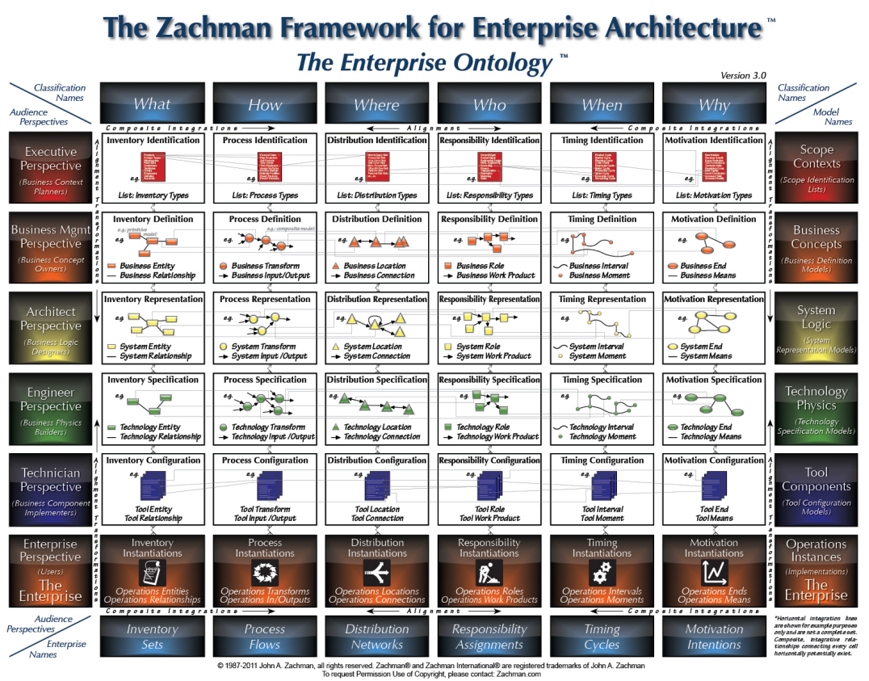

In addition to the widely used frameworks TOGAF or Zachman, which are designed not only but primarily for enterprises, there are further frameworks. The Department of Defense Architecture Framework (DoDAF) in the USA has developed its own framework for its special requirements. Since Department of Defense matters are military activities, various stakeholders, such as those of defence agencies or combat commands, have to be taken into account. In addition, priorities and strategic goals differ, making the enterprise architecture different from any other organisation. In DoDAF, there is a high focus on visualisations to understand complex architectures, making it particularly suitable for large systems. (U.S. Department of Defense 2009, p. 3) The US is not the only country that has developed a framework for military purposes. Other military and political organisations have created their own EA frameworks based on DoDAF, such as Ministry of Defence Architecture Framework (MODAF) from Great Britain which has been withdrawn and replaced in 2021 (GOV.UK 2012, p. 1) by the North Atlantic Treaty Organization (NATO) Architecture Framework (NAF) (North Atlantic Treaty Organisation 2022, p. 1).

## 3.4 IT Demand Management

An important and closely related competence for EA is IT Demand Management (IT-DM) (Khosroshahi et al. 2018, p. 1). As mentioned in chapter 2, IT-DM is a part of strategic IT governance. Symons describes IT-DM as a critical process of IT governance to understand business needs and allocate IT resources accordingly to optimise business value (2006, p. 1).

In the ITIL framework mentioned in chapter 2, the goal of IT-DM is described as “to understand, anticipate and influence customer demand[s]” for IT departments (2022, p. 1). It is thus the direct intermediary to mediate and translate IT demand and supply between the internal customer which is the business and IT (Helmke and Uebel 2016, pp. 41). For this purpose, an IT demand manager records the business’ demand request including requirements. In cooperation with the business, it is the responsibilities of IT to analyse, classify and prioritise the demand requests in order to identify the most crucial changes and to discuss possible solution approaches. Afterwards, the demands are aligned with the corporate strategy and the enterprise architecture for instance as part of the TOGAF requirement management phase in the ADM cycle. If necessary, the demands are subsequently implemented in the form of specific projects. (Rüter et al. 2010, pp. 161) Without suitable processes and governance, many small projects would run without any beneficial effect for the company as a whole, which is why an IT-DM structure is necessary. It is an essential prerequisite for the efficient and effective use of IT in the interest of the company's goals. (Helmke and Uebel 2016, pp. 62)

The different demands can be divided into three categories altogether: operational, tactical and strategic (Alonso et al. 2013, p. 902). Operational demand is the management of IT resources to run the core business. Tactical demand is day-to-day and routine demands that often require only minor changes. Strategic demand is of a larger scale and usually involves projects with a strategic impact on the business, such as the implementation of a new Enterprise Resource Planning (ERP) system. (Mercury Corporation 2006, p. 4)

IT demand management has a high value because it is advantageous in several ways. Through a direct interaction between different business units and IT as a central intersection collecting many different demands, decisions can be made more accurately. This enables IT to allocate resources more efficiently, which can support business goals in a more target-oriented way. Hence, resources are directly aligned to the EA strategy. Resulting a higher service quality of IT, so that business expectations can be realised easier and lead to an increased user satisfaction. From a financial point of view, avoidable expenditures in the company can be prevented, as investments are only made for IT resources that are actually required. (Helmke and Uebel 2016, pp. 77–79)

# 4 Business Capability Management

EA provides a structured approach to understanding the current state of an organisation in relation to BC (Tiemeyer 2023, p. 147). By examining a BC, the baseline architecture is determined. As stated in “category 1 – assess” in chapter 3.2, insights can be gained on areas for improvement (Kamath 2011, p. 12). A BC is a definite consideration object of EA. Particularly the accountable enterprise architects thus know exactly what they need to focus on in enterprise planning. The common understanding of concrete BC in the company creates a common language between business and IT. This facilitates it for organization stakeholders, to make sure that IT activities are in line with corporate objectives. If the capabilities are complemented with further information, they offer an appropriate foundation on which to base strategic IT decisions. (Bondel et al. 2018, p. 125)

In the following, the concept of BC is explained, its benefits for improving EA are presented and ways to analyse a BC are presented.

## 4.1 Definition of a Business Capability and its elements

The term "business capability" is defined inconsistently in the literature (Khosroshahi 2018, p. 28) and is often presented in a fragmented way (Offerman et al. 2017, p. 383). While the Cambridge Dictionary simply refers to “capability” as “ability to do something” (2023, p. 1), BC can be described as a company’s ability to fulfil a necessary task in order to accomplish a certain business goal and support the organizations success (Sabean 2013, p. 1). Other researchers explicitly emphasise that technologies, resources and processes used are not primarily relevant to define a BC (Fleischer et al. 2007, p. 188). However, a variety of other sources suggest the opposite, which consider BC as the actual use of tangible and intangible assets for the execution of performance-improving activities (Acar and Zehir 2010, p. 692). A straight-forward approach is provided by TOGAF. Here, BC are described as “what a business does without attempting to explain how, why, or where the business uses the capability”. TOGAF specifically stress that they simply have to exist and not in what extension or quality they are or need to be realised.

Creating a BC starts with naming the capability as illustrated in figure XY. According to The Open Group’s framework, the following things need to be considered. Firstly, the capability must be clearly distinguished from the others by name. Secondly, the naming should be done in a noun-verb format. The result such as strategy, product or project is represented as a noun and the respective activity such as delivery, planning or monitoring as a verb. This naming convention is intended to focus on the business object, which is a single and persistent item (e.g. strategy, product or project) and barely changes throughout the existence of the business. This serves to facilitate the identification of the information objects related to the BC. (The Open Group 2022d, pp. 6) In addition, it serves as a control not to equate the BC with the name of a department, e.g. transaction recording instead of accounting (Cook 2007, p. 5). One recommendation of the framework is to select names that are appealing to management and stakeholders. This promotes better understanding and clearer communication between different participants. It is explicitly advised against using departmental names as a basis for naming the capability since these are merely corporate structures and often do not endure and are subject to irregular change. BC are inherently more long-lasting; after all, in most companies a product is always being produced or a strategy planned quite independently of the organisational structure. (The Open Group 2022d, pp. 6) This emphasises the focus on the stable *What*, rather than surroundings such as the *Where* organisational structure that as per a McKinsey survey often changes every two or three years according to 70% of the interviewed executives (2014, p. 2), the *How* such as processes that can be subject to continuous improvement change (Adams et al. 1999, pp. 767) or the *Who* represented through the employees that are changing their workplace in average every five years following the Human Capital Benchmarking Report by the Society for Human Resource Management (2017, p. 4). The emphasis on the *what* is merely logical. If it changed, the organisation would no longer be the same. (Graves 2023, p. 117)

The naming of the BC is followed by a short description in order to elucidate the scope and objective of the BC and to separate it from other capabilities. Again, special attention should be paid to language that is relevant and appropriate for stakeholders. Specifically, TOGAF lists two requirements when describing the capability. Both aim to be concise and precise enough in a few sentences to provide enough detail for better understanding without repeating the exact wording of the capability’s name. A possible description for the BC “Product Development” could be: the ability to design and create a product or service that meets customer needs. (The Open Group 2022d, p. 7)

There are four components that help to refine and enable a BC. The components enable four different perspectives, which are roles, processes, information and resources, and will be explained in further detail in chapter XY. Since a BC only represents what the business does, they help to understand how a BC is realised and implemented. The distinction between the what and the how is necessary for the following reason. Typically, a BC outlasts a longer time frame. Its realisation, on the other hand, is the object of regular changes (The Open Group 2022d, pp. 7).

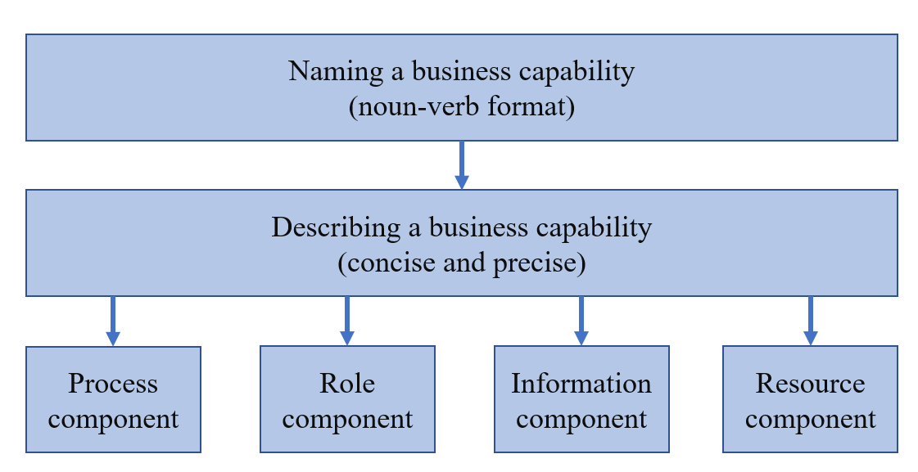

Figure 7: Elements of defining a business capability (own illustration)

## 4.2 Business Capability Mapping

After presenting the meaning and background of BC, the practical application in the form of BC mapping is explained in the following. BC mapping is a central step in EA to identify the different BC of an organisation in order to get an overall picture of the company and its capabilities (Reinhard 2015, p. 83). With the help of the BC Map, a summary of all the core functions of the organisation can be presented visually on a single page of paper (Graves 2023, p. 116). Both the current situation and the desired target architecture can be depicted (Reinhard 2015, p. 83). Hence, this approach can be assigned to the TOGAF ADM architecture vision phase as part of the business architecture layer to provide a consistent view of the company explained in chapter XY (The Open Group 2022n, pp. 6).

The first step of BC mapping is to record and document all existing BC in the company. TOGAF recommends a top-down approach. Thereby, the 20-30 BC at the highest level are identified, which are later refined downwards in greater detail. The required information can usually be gathered from three sources. The first point of reference is the organisational structure. The different areas of the company are closely aligned with the BC to some extent and can thus be used as a basis for mapping. (The Open Group 2022d, p. 9) It must be noted, that the organisational chart cannot be directly transferred to the BC map. Often several business units are involved in the execution of one single BC (Grant 1996, p. 378). Another source for mapping can be the company's business model. If such a model exists, individual BC can be derived from it since they represent the building blocks of the business model. The third source for mapping is published corporate strategies and operational business plans, which can be used to identify further BC.

After determining all relevant BCs of the company, the second step is to arrange them logically. In this process, the BC are classified, grouped and placed in different levels of the map. The purpose of this categorisation is to make the BC map comprehensible. One way of dividing them is into strategic, core and supporting BC. Each of these three BC offers a different perspective for the different stakeholders of the company, as already indicated in chapter 2. A further distinction is the so-called levelling. This involves splitting and subdividing top-level or level-1 BC into lower granular levels. This helps to communicate the BC at different stages, as it is in the interest of the stakeholders. According to TOGAF, a map can in practice be divided into up to six levels. (The Open Group 2022d, pp. 12–14)

A comprehensive example BC map is provided by LeanIX (2023b, p. 3). For reasons of clarity, it is not illustrated in this thesis. However, the BC map of Linde plc is presented in chapter XY. The use of standard maps is suitable for most companies. The type and elaboration of a BC map is typically very sector-specific. (Graves 2023, p. 117) Large parts of the map are identical across companies. For example, there is a BC for "Develop Product/Service", "Generate Demand" and "Deliver Product/Service" in every company, regardless of the industry. (Reinhard 2015, p. 84) Differences often only emerge at the lower levels. However, these are the relevant ones for the competitive advantages and success of the company. (Kamath 2011, p. 13)

Once all relevant BCs of the enterprise are illustrated in a map, heat mapping can be used to work towards the target architecture. In heat mapping, BCs that are not performing optimally are coloured differently (e.g. red) than BCs that are performing well (e.g. green). (The Open Group 2022d, p. 15) From this, it is possible to derive and illustrate concrete and strategy-relevant decisions (Reinhard 2015, p. 84). There are various ways of viewing this. Khosroshahi has examined those in two publications. Some selected ones focus on investment decisions, among other things. Deficient core BCs, for example, have a higher priority in this regard. Furthermore, it can be investigated which BCs do not fit into the business strategy or which are suitable for outsourcing because of too high operating costs and too low competition advantage (Khosroshahi 2018, p. 32). In addition, there are further viewpoints, which, however, would go beyond the scope of this paper (Khosroshahi et al. 2018, pp. 6). Furthermore, the BC map also supports IT-DM (Reinhard 2011, p. 30). For instance, a demand for the introduction of a new Customer Relationship Management (CRM) system could be submitted as a request. The IT-DM team can then identify with the help of a heat map whether the corresponding BC (e.g. customer management) is not sufficiently supported by IT in its current state and whether a corresponding new CRM system would improve the to-be state. (Reinhard 2015, p. 87)

For this reason, the BC map is a popular EA artefact, as it provides an overarching view of all business functions that form the company's business model and reflect the corporate strategy, thus presenting an overview of the entire enterprise (Bondel et al. 2018, p. 125). Hence, it serves as a common ground to find the right balance between business interests and IT capacity (Brooks 2009, p. 2), enhancing the strategic dialogue between business and IT in future investment decisions and the work of enterprise architects (Kotusev 2019b, p. 6).

## 4.3 TOGAF artefacts to analyse Business Capabilities

Once all relevant BCs have been identified, named, described and mapped together, the BCs can be examined more closely in order to make the architecture of them more efficient.

TOGAF provides so-called artefacts as part of the ADM as mentioned in chapter 3.3.1 in the section of the TOGAF Fundamental Content. (The Open Group 2022m, p. 10) Artefacts are used to depict the actual state of the organisation and its EA on an abstract level (Kotusev 2019a, p. 1) and to present the information in a way that is understandable to the stakeholders. While the enterprise architect tries to keep the big picture in mind, the stakeholders are only interested in some specific aspects of the EA. To meet these requirements, artefacts in the form of catalogues, diagrams and matrices are used. These help for clear and understandable communication with stakeholders to ultimately manage and maintain the EA.

* Catalogues are lists or tables that contain an inventory of all elements relevant to the architecture. For example, a catalogue can provide information about applications, data, processes or infrastructure components. Thus, a catalogue helps to obtain a comprehensive overview of all architectural elements. (The Open Group 2022m, pp. 10) At the same time, this form of artefact often serves as the basis for matrices and diagrams (Abraham 2013, p. 9).
* Matrices are also referred to as grids. They represent the relationships between two or more different architectural elements. This method of documentation can be used, for example, to identify dependencies between elements.
* Diagrams are graphical representations to present architectural content in a simplified way. They also support as a technique to check the architectural content for completeness. Often, deficiencies in the documentation of the EA become apparent when diagrams are created, as they are easily visually apparent through the graphical form of presentation, in contrast to catalogues or matrices. (The Open Group 2022m, pp. 10)

TOGAF lists dozens of concrete representation forms for artefacts for the ADM phases A to E, with a focus on the phases of business, information system and technology architecture (B, C and D). These artefacts can be used in a detailed illustration of BC (Kotusev et al. 2023, p. 3).

Although TOGAF supports the presentation of a BC with a variety of suggestions for the use of artefacts, criticism can be stated at this point. While it lists the types of artefacts that can be modelled, in most cases it does not address how and, more importantly, for what purpose they should be documented. Many of the artefacts are only mentioned in a single sentence by TOGAF. (Kotusev 2019a, p. 1) It seems that neither TOGAF nor other EA literature illuminates the practical use of the artefacts or what purposes the documentation serves for stakeholders in various use cases (Kotusev et al. 2020, pp. 1). Moreover, researchers claim in a publication from only 2023 that they have for the first time in literature analysed EA artefacts in detail in regard of business and IT alignment and examined them in practice (Kotusev et al. 2023, p. 13).

This means that enterprise architects are faced with the challenge that although there are guidelines and recommendations on what content should be documented, only limited information is offered on how this should ideally be achieved. From a practical point of view, this is understandable, because companies often only have the general goal of shaping and controlling the company with the help of EA. The individual requirements, however, usually differ significantly depending on the industry or the size of the business. (Roth et al. 2013, pp. 6–8) A company must therefore define for itself when the required depth of EA modelling and BC documentation has been reached. It should be noted that the effort for documentation increases exponentially with the depth of detail. (Davis 2005, p. 20) In chapter XY of this thesis, artefacts are used to describe and analyse a BC in practice taken the example of Linde plc.

# 5 Corporate IT demand management at Linde plc

To handle demands, Linde is using a central web-based application called Global Portfolio System (GPS). The system consists of four different areas, which is addressed to different business areas which is shown in figure XY below. The focus for this thesis is on the corporate IT demand management process. However, a brief comparison of the financial scope of the different demand processes may explain why Linde is executing its IT demands the way they do.

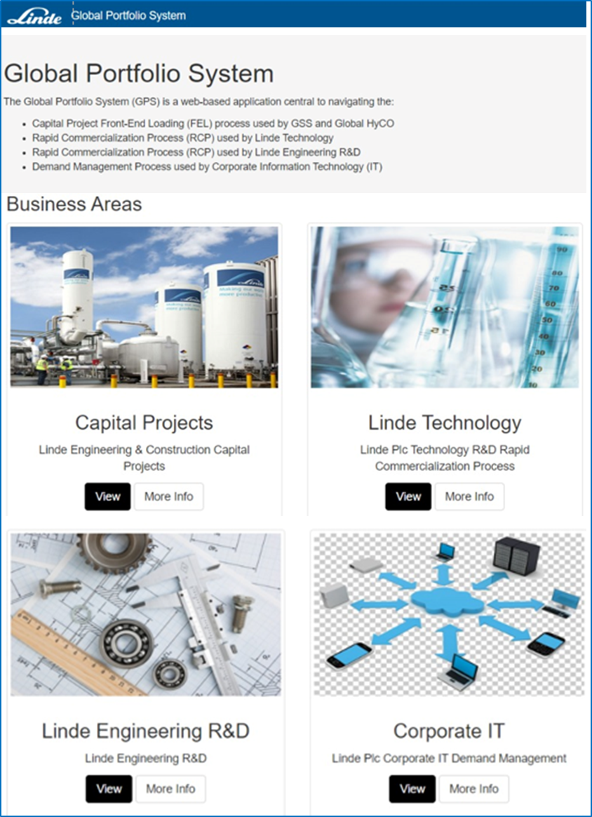

Figure 8: Excerpt from the Global Portfolio System showing the different demand management areas (Linde plc 2023c, p. 1)

The three sections starting from the top left are dealing with construction projects from the business unit Linde Engineering, as well as research and development projects from Linde Engineering and Linde Technology (Linde plc 2023c, p. 1). These demands, which later lead into a project often run into millions – occasionally into triple digits. Examples are projects such as air-separation units (ASU) in Nürnberg with investments of around 50 million euros (Chemie Technik 2019, pp. 1) or in Eisenhüttenstadt for 85 million euros (Bittermann 2017, pp. 1) are latest examples of Linde Engineering Germany activities. Even more impressive is a project in Texas. Here, Linde plans to build an on-site complex at the ammonia plant site of the chemical company OCI Partners LP. The financial scope of the project for the entire development period of several years is $1.8 billion. (Linde plc 2023e, p. 1) Due to the high financial implications, Linde has carefully planned and developed these demand processes. SOURCE

The corporate IT demand process, on the other hand, has a different priority in the company. Before the process is presented below, a limitation must be set. At Linde plc, the IT organisational structure is decentralised and consists of independent regions with their own autonomous IT teams. They are responsible for ensuring that the IT infrastructure, applications and systems in their region run efficiently and lead IT projects and initiatives within their region. In addition, there is the corporate IT team, which is the equivalent of the global IT team. However, its decision-making authority is limited to specific areas such as cybersecurity strategy and other governance issues. Therefore, the corporate IT demand process only deals with demands that fall into the strategic category as explained in chapter 3.4. Operational and tactical changes, on the other hand, are performed in the regions (Linde plc 2021d, pp. 11–20).

Due to the scope of IT investments, Linde did not fine-tune their corporate IT demand process. However, no precise financial figures are measured for the impact of IT projects. In practice, this is difficult because the projects are driven by cost avoidance, cost reduction, profit growth, obligatory regulations or as strategic investments and therefore the exact financial impact cannot be calculated and usually occurs in the future. Furthermore, although projects are initiated at the global level of corporate IT, they are often implemented by regional IT teams in the countries. This also complicates the recording of accurate financial data. (Linde plc 2023c, p. 2) QUELLE ANJA

Nevertheless, Linde invented and elaborated their own methodology for the corporate IT demand process, the STEPS methodology. STEPS is an acronym for Standards & Tools for Project Success and is based on international project management best practices, in particular on the Project Management Institute (PMI). It is a set of methods, processes, practices and tools that are repeatedly carried out to deliver projects. The key element is that Linde’s corporate IT gains efficiency in its approach by repeating the same actions on every project. Through such a framework, there is a common set of steps and processes from initiation to delivery of projects for all involved people. By providing checklists, examples, best practices, and leveraging learnings from previous projects, STEPS increases the likelihood of project success at Linde plc.

The STEPS project lifecycle is divided into seven phases as shown in figure XYZ.

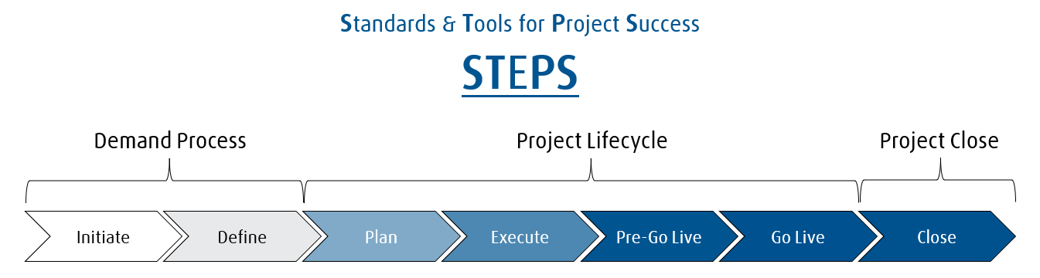

Figure : Stages of the STEPS methodology (Linde plc 2023b, p. 6)

The two phases "initial" and "define" already represent the complete demand process. Here, the need for a change is registered and then defined in more detail. If the demand is identified as reasonable, a project is planned and implemented until the change can go live and the project can be declared as finished. Theoretically, an IT project does not require a demand pre-process. After all, any change request can be implemented directly in a project. The reason why Linde puts a stop to this is as follows. On the one hand, IT can enable faster processing of the demand, since it can fall back on existing solutions. Furthermore, business requirements are to be met, while at the same time controls and IT architecture are to be considered in accordance with corporate and regional strategies. Corporate IT’s own aspiration and goal here is to ensure that the demand process encourages regions to participate because they will benefit, not because they are prompted to do so.

Not all IT initiatives are captured in the GPS. For example, regional IT project managers and IT directors decide, based on the level of risk associated with the demand, whether it is managed as a project or a change. Only if the demand is considered as a project, a GPS entry is required. Apart from that, there are conditions where the demand must be recorded in the GPS.

* The request is for a new service/solution
* The request is for a replacement of an existing service/solution
* The request is for a significant change to an existing solution design/landscape
* The cost is greater than $30k (US) *– initial estimate*
* The effort is greater than 100 days – *initial estimate*
* The request relates to a corporate IT managed application
* There is a dependency on corporate IT resource
* The request requires corporate IT capital expenditures (capex)

When the person or team who raises the demand is in doubt whether their demand falls under the GPS conditions, then they are asked to contact the project & standards, architecture or security team. (Linde plc 2023b, pp. 4–6)

To submit a demand, a form must be filled out in the GPS. The most important information required is listed and divided into different sections in table 1 below.

Table : Required information for a demand request in the Global Portfolio System

|  |  |  |  |
| --- | --- | --- | --- |
| **1. General** | | | |
| 1.1 Demand name | | | Name of the project that explains the objective in a few words |
| 1.2 Requirements/   Opportunities | | | Answers why the demand has been raised, what problem needs to be solved or what opportunities are offered |
| **2. Categorization** | | | |
| 2.1 Funding/ affected   business unit | | Business unit that will pay for the project or will be affected by the future project | |
| 2.2 Process area | | The process area is used to notify subject matter experts of the demand request so they can provide their input to the review of the demand request (e.g. finance, cylinder supply chain) | |
| 2.3 Number of users   impacted | | Estimated number of internal users who will be impacted by the implementation of this request (used to assess potential risk) | |
| 2.4 Business drivers | | Possible selections   * Cost avoidance / risk mitigation/ run the business * Cost savings / cost reduction * Growth / increase capability * TLS (tax, legal, statutory) * Strategic investment | |
| 2.5 Benefits per year/   benefit duration/   benefit start | | Net productivity during a full 12-month period  One-time benefit / recurring benefit  Date, when the benefit will start to be realised | |
| 2.6 Consequences of not   implementing   demand | | Description of the consequence of doing nothing (e.g., business will remain unable to meet growing customer requirements or business will not be compliant with local legislation and will incur a fine) | |
| **3. Involved persons** | | | |
| 3.1 Sponsor | Senior business representative who wants the change and is overall accountable for the project/ change | | |
| 3.2 Request owner | Single point of contact regarding any questions related to the demand and for progressing any actions required to drive the demand request through the process. The request owner must be within IT | | |
| 3.3 Project manager | Responsible for the successful execution of the project | | |
| **4. Estimate project** | | | |
| 4.1 Estimated internal   IT effort (in days) | Amount of internal resource effort required to implement the solution including corporate IT and regional IT resources | | |
| 4.2 Estimated total IT   costs (in USD) | Only costs that are IT related | | |
| **5. Technology** | | | |
| 5.1 Application | List all corporate IT supported application or any other application that are affected by the demand/ change | | |
| 5.2 Changes or creation  of interfaces | Selection of either “Yes” or “No” and a comment of the request owner must be added so that the demand committee are aware of the concern. | | |

(Linde plc 2023c, p. 5)

When filling out the form, the request owner needs to remember that other people do not know about the described system, change or project. Therefore, it is crucial to add as much detail as possible. When the demand requestor enters data into GPS, they must ensure that the request is clearly described to prevent additional questions from the review team to prevent any delays. Furthermore, for all new applications or changes to an existing application supporting documentation must be provided clearly showing how all architecture elements fit together. In parallel with the demand request, a risk assessment must also be carried out. All new projects and enhancements that include an IT component must go through IT security processes to ensure that security concerns are addressed at an early stage and that security requirements are incorporated from the outset. With the submission of the request in the GPS through the request owner, the corporate IT demand process is started. Figure 10 illustrates it.

In a recurring meeting, the newly submitted demands are reviewed and discussed. Participants include the demand manager and several IT colleagues who provide technical support in evaluating the requests and who have to approve them collectively. This team is called demand committee and includes experts in three different areas: functional, architectural and security. After all contributors have aligned their viewpoints, the demand request is either approved or not. If the decision is positive, the demand is forwarded to the responsible regional IT director. They are then responsible for confirming the recommendation made by the corporate demand committee. In addition, they must prioritize the project for realization and ensure funding and the availability of local resources. However, if the demand committee decision is negative and the application is thus rejected (for the time being), additional processes must be interposed. After the rejection, it is assessed whether the quality of the application is acceptable. If not, and the information provided is not sufficient to understand the basic concept, the request is dismissed entirely. Consequently, the applicant must retry, with greater specifics, more comprehensible explanations and descriptions, and relevant documentation. In the case of a rejected but qualitatively acceptable request, the demand team will review the request again. In this situation, further information is usually obtained from the request owner until the request can pass. Here, too, the request is then forwarded to the regional IT director for further action. (Linde plc 2023b, pp. 13–18)

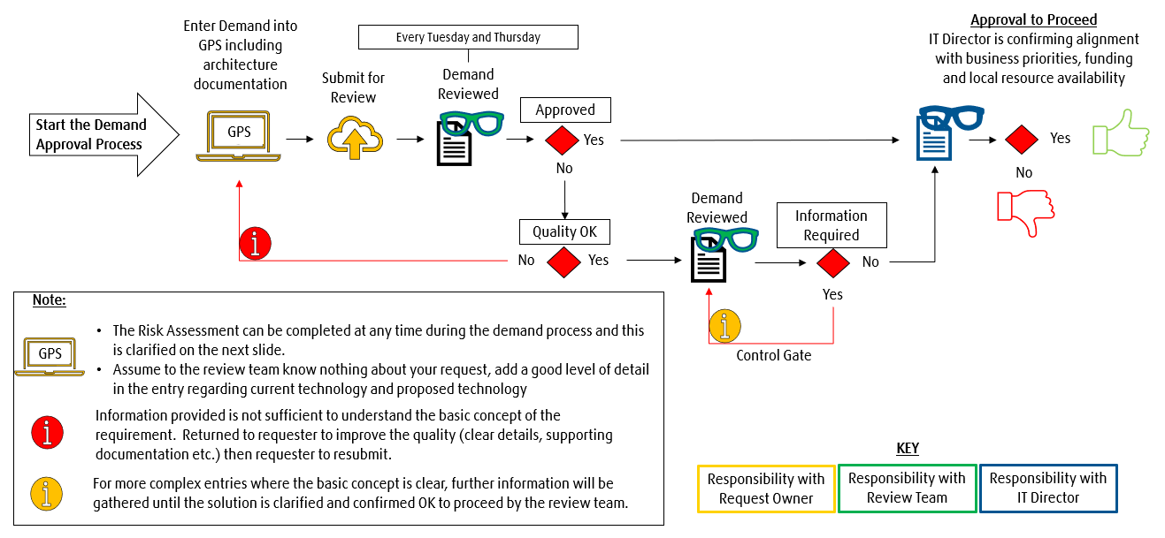

Figure 10: Corporate IT demand process (Linde plc 2023b, p. 15)

The specific part of the demand review is particularly critical. Especially from a functional and architectural point of view, there is no stringent procedure, how to decide whether the demand should be approved and executed in a project. The demand committee decides and plans the project without a guideline or a methodology such as TOGAF but solely on basis of their own personal knowledge and their work experience. (Linde plc 2023b, pp. 15) Quelle Interview This is the point of intervention addressed in the further course of the bachelor thesis.

# 6 Business Capability Management at Linde plc

The following chapter describes how the BC management introduced in chapter 4 is implemented in practice at Linde plc. First, it is explained how Linde is currently using BC. This is followed by an analysis of a concrete BC based on the TOGAF methodology in a cross-country comparison. The aim is to find out how a BC analysis needs to be addressed and whether the approach should become part of the IT-DM at Linde in the future.

## 6.1 Business Capability Map

In the past, there was only once an initiative that nearly led to an establishment of BC Management at Linde. However, due to the merger with Praxair mentioned in the introduction, which was implemented in 2018 shortly after the start of the BC initiative, the project was discontinued due to low priority. (Linde plc 2018a, pp. 1)

The only remnant of Linde’s BC initiative is a rudimentary BC map, as shown in figure XY. It visualizes the most important core capabilities of the company which particularly represent the value chain. In total, Linde’s map is divided into five key areas or level 1 capabilities, which are subdivided into further level 2 and level 3 capabilities. (Linde plc 2017, p. 1)

* Market Offer Management is responsible for identifying and developing new products and services that meet the needs of customers. This area is in charge of creating value propositions, conducting market research and analysing customer feedback to develop and market effective offerings. (Stark 2022, pp. 37)
* Customer Management focuses on building and maintaining customer relationships by providing service and support. This segment is responsible for managing customer accounts, resolving customer issues to ensure customer satisfaction. (Salomann et al. 2005, pp. 392)
* Order-to-Cash is an important business function that covers the entire process from the customer's order to the receipt of payment (Shopify 2022, p. 2).
* Supply Chain Management - Cylinders & Hardgoods focuses on the procurement, production and delivery of physical goods, such as cylinders and other hardgoods. This capability is responsible for managing the entire supply chain.
* Supply Chain Management - Bulk is similar. However, this capability focuses on the management of bulk goods such as gases. This segment is responsible for the logistics of moving large quantities of products from production facilities to storage facilities or directly to customers. (Voigt 2018, p. 1)

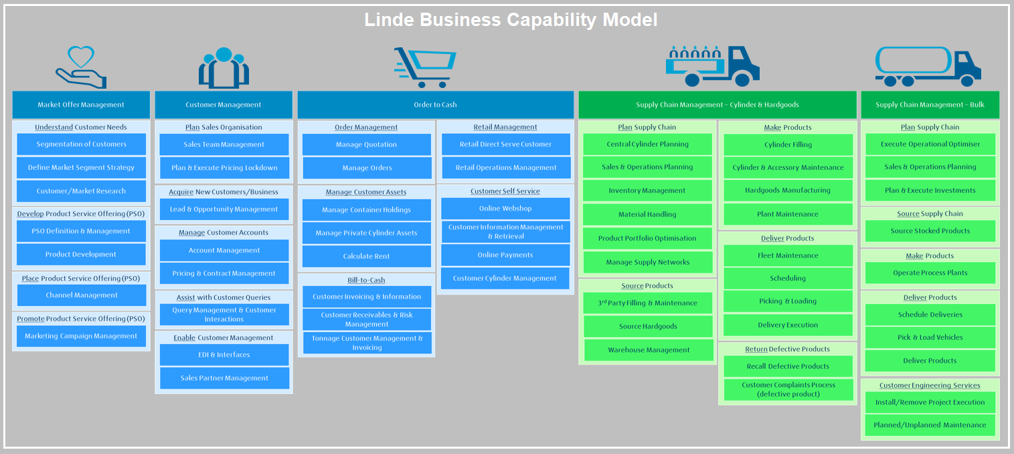



As mentioned, the use of BC at Linde was abandoned after the merger. Only in one project, the BC were needed again. In 2021, Linde decided to create an application inventory. An application inventory is part of the application portfolio management. All system applications present in the company are recorded in a central inventory database. Due to a lack of documentation, growth through mergers & acquisitions activities and so-called shadow applications used by the business without IT's knowledge, IT at Linde did not have an overview of its entire application portfolio. Through the introduction of the application inventory, all applications were then captured and described with around 100 attributes. To better manage the applications, an attribute that is referencing BC is used. An attempt was made to identify all capabilities in the organisation and assign them a unique number. Unlike the BC Map, the focus was not only on the core capabilities, but on all of them. (Kuchenbauer 2021, pp. 13–17) This resulted in a list of twelve Level 1 capabilities with a total of about 270 individual capabilities. Figure XY lists exemplary the level 1 capability Human Resources with its level 2 sub-capabilities.

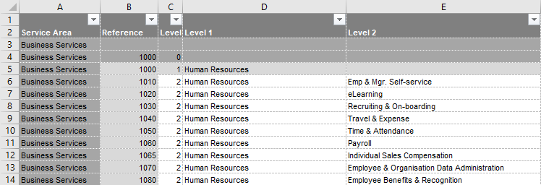

Figure : Extract from the business capability reference number list for the application inventory (Linde plc 2021a, p. 1)

If someone filters the application inventory by BC reference number 1030, you can see all Recruiting & On-boarding applications existing at Linde worldwide. If a country or a BU is looking for a new solution for their internal processes, they can orient themselves on the solutions already available in the company. This allows the application landscape to be streamlined and costs to be reduced through possible license savings or support services. (Linde plc 2021a, p. 1)

Since then, this thesis is the first attempt to reintroduce the use of business capabilities at Linde plc.

## 6.2 Business Capability analysis across international regions

In this section, the analysis of the specifically chosen BC “Deliver Product” is carried out. First, the BC is delimited and described. Afterwards, it is presented and analysed how Deliver Product is executed, once in Korea and then in Germany. For this purpose, the TOGAF artefacts mentioned in chapter 4.3 are used in practice. In addition, this section also addresses two research questions. How can a BC be analysed across international regions and what are differences and commonalities in the execution of the core capability “Deliver Product” in Korea and Germany?

What is the goal of a BC analysis? See notes in my papers….

### 6.2.1 Business Capability “Deliver Product”

When performing an evaluation of the Deliver Product BC, it is necessary to define what exactly and to what extent the scope is to be considered.

Since Deliver Product appears twice in the BC map, it must be emphasized that the BC to be reviewed focuses only on Linde's cylinder business, the Packaged Gas Products (PGP) business (in Linde’s BC map called Deliver Product – Cyl). It is one of Linde's three core gas businesses. Linde's core gas business consists of the following segments, as illustrated in Figure XY.

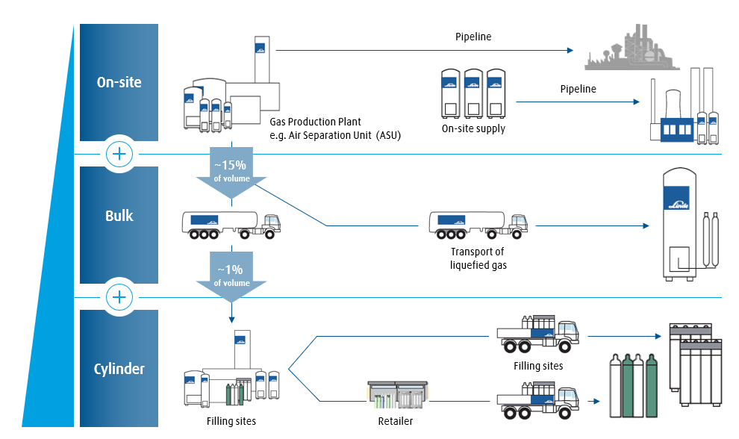

Figure 12: Linde's largest gas business segments (own illustration)

Linde constructs plants, such as ASU, for the production of gases. Most of the gases, 85%, are transported directly to the customer via pipelines, also known as tonnage or on-site business. Frequently, the plants, some of which cost billions, are located directly on or at the customer's site. 15% of the gas produced is distributed through the bulk business. Trucks loaded with the liquified gas drive to the customer's site and fill the vessels there. (Anon 2023h)

Only a tiny proportion of the production is filled into cylinders and then sold as individual products or packed together in bundles as shown in picture XY. The picture shows typical, standard cylinders, which are sold in this shape and size all over the world by Linde. This is the PGP business. Although it is negligible in terms of volume, this is where the largest profit margins are made. Linde operates its own retail stores and offers the products there. In general, however, the cylinders are usually delivered directly to the customer. (Linde plc 2021e, pp. 3)

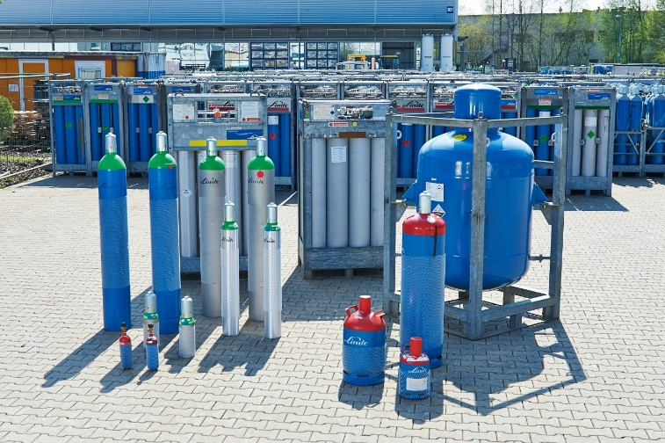

Figure 13: Linde's standard gas cylinders in different shapes and sizes (Linde plc 2021e, p. 48)

The BC presented relates only to the PGP cylinder business. With reference to Linde’s BC map, Deliver Product is a level-2 capability of the higher-level capability “Supply Chain Management - Cylinder & Hardgoods” and is divided into the four sub capabilities “Fleet Maintenance”, “Scheduling”, “Picking & Loading” and “Delivery Execution”. (Linde plc 2017, p. 1)

When performing an analysis. the business capability model does not expect a representation of the processes in the finest detail. It is important that the reader - regardless of whether from the business side or from IT - understands how the capability is executed. Furthermore, it must be clarified where the BC sequence to be documented and analysed begins and ends. A holistic view of the BC is required in order to be able to deliver added value and support the capability in the best possible way.

In order to analyse a BC in concrete terms, the procedure described in graph XY in chapter 4.1 is applied. Once the BC has been named, it must be described and classified precisely and concisely. For the BC “Deliver Product”, the following statement was defined at Linde.

*“The “Deliver Product”-capability starts with the registration of the customer’s desire and ends when it is fulfilled, and the customer is satisfied.” (Anon 2023a)*

Consequently, not only the literal interpretation of the delivery to the customer is the focus of the analysis. Instead, all neighbouring and direct upstream capabilities relevant for the delivery of a product must also be included. This means that the higher level-1 capability must also be reviewed and related capabilities need to be linked since they in some cases might have impact on the original BC. INTERVIEW Seite 8-9

### 6.2.2 Execution of Deliver Product in Korea

After the BC is named and described, the procedure in Table XY continues with the description of the four components processes, roles, information and resources. However, some background information is added in this examination to provide a holistic understanding of Deliver Product in Korea. Since TOGAF does not represent a rule but only best practices, the framework can be adjusted as preferred.

#### General Information (Korea)

The BC review starts with a brief demonstration of key financial, non-financial metrics and general information about the business to be analysed. This allows to gather a sense of the size of the BU. Sometimes initial conclusions can already be drawn from this presentation. Table 2 presents the main general information below.

For the BU PGP Korea, 70 full-time employees (FTE) are directly engaged in supplying about 300 customers. Quite unique for Linde is that PGP Korea is very dependent on eight major customers. These eight are responsible for significantly more than three quarters of the total orders. Korea owns 30,000 cylinders, all of which are sold a little over three times a year on average.[1] This generates an annual turnover of 195 million euros. The business unit is therefore comparatively small. Nevertheless, it has the fastest revenue growth of all PGP units in The Linde Group. (Anon 2023e) Although customers from a wide range of industries are supplied, PGP Korea is strongly focused on the electronics industry, especially for chip manufacturing. Almost all gas products can be classified in the specialty gases (SG) sector, where they are produced and filled in two plants in the whole country. SG are very complicated to produce. Often gases rarely found in air are used.[2] Depending on customer specifications, various gases must be mixed. As a result, a single cylinder in Korea can cost up to one million euros. The average cylinder is priced at approximately 2,000€. (Anon 2023b)

Table : General information about PGP Korea

|  |  |
| --- | --- |
| **PGP Korea** | |
| Employees PGP Korea in FTE | 70 |
| Revenue of PGP Korea in million Euros | 195 |
| PGP customers | 300 |
| Own cylinders | 30,000 |
| Sold cylinders per year | 100,000 |
| Price of products | Very pricy gas products that cost around two thousand euro in average but also up to one million euro per cylinder |
| Main products | SG for electronics industry, especially semiconductor industry |

(Anon 2023b)

#### Process (Korea)

In order to understand how a BC is delivered, it is essential to look at the fundamental processes. Only by identifying and analysing the process, the BC can be compared with another BC as well as their implementation and optimised if necessary. The analysis also provides the basis for coordinating the three other BC components: roles, information and resources. (The Open Group 2022d, p. 8)

Two TOGAF artefacts were chosen to represent the process component. Figure 14 is a modification of the process flow diagram. An attempt was made to show the entire process on one page, including the people involved. To get a good overview of the BC, this figure is placed on the beginning of the analysis of the process component. The purpose of process flow diagrams is to depict the sequential flow of all related activities using the swim-lane technique based on the business process model notation. The diagram has been graphically simplified by the use of icons. This artefact provides a basis for understanding the entire BC Deliver Product. As such, it is useful for elaborating the architecture with different stakeholders. (The Open Group 2022m, p. 17) The Process/Event/Product catalogue in table XY serves as a supplement to process flow diagrams. It contains the same information, but presents it in a different way. In practice, such a catalogue can be used to filter certain process steps and query them in a database-like way, for example to identify similarities or differences in the execution of the BC in various countries. It contains a list of all process sub steps, the events that cause the processes, controls that serve as preconditions and the product which is the outcome of the process sub step. (The Open Group 2022m, p. 14)

Overview: Process Flow diagram

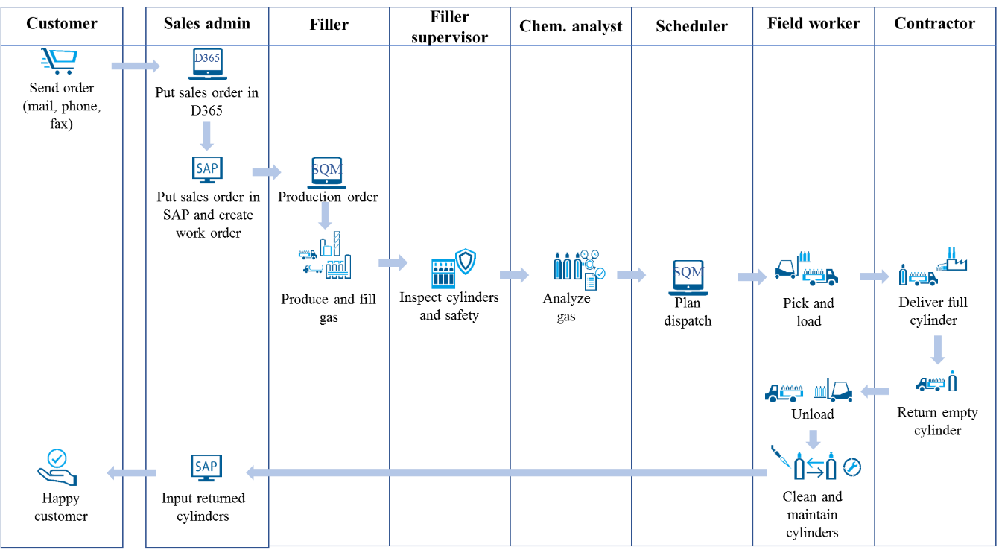

Figure 14: Process flow diagram - PGP Korea (own illustration)

The following describes the Deliver Product process from the representation in Figure XY and Table XY. A verbalisation is necessary because parts of the background information cannot be conveyed by the artefacts.

The Deliver Product process starts with the arrival of the customer order in the customer relationship management (CRM) system. In this context, the exact customer requirements are captured. As mentioned above, Korea PGP mainly supplies SG. For this purpose, Linde requires precise information on the composition of the gases for production. This involves that the customer specifies the exact ratio of the individual gas molecules for his order.

From the CRM, it is automatically forwarded as a sales order to the central SAP system, the enterprise resource planning (ERP) system. A work order is then created to process the sales order. To inform the employees what kind of gas is to be filled or mixed, they receive a production order in the Samsung Quality Management (SQM) application.

After receiving the order, the gas is produced by absorbing air from the environment, breaking it down into its elements and filling it into cylinders in the mixture desired by the customer. For safety reasons, the cylinder is inspected visually and examined from the outside. Provided this is without objection, the quality of the gas is analysed[3]. This is necessary because even a slight deviation in the composition of the SG can have fatal consequences and cause great damage during further processing by the customer. Therefore, a purity of the gas mixture of (depending on the mixture, almost) 100% is essential. The analysis data are entered in the SQM and, if the quality result is positive, a so-called Certificate of Analysis (CoA) is issued as confirmation for the customer.

After the product is completed, inspected, and tested, the dispatch to the customer is scheduled. The cylinders filled with gas are taken from the inventory and loaded onto a truck. The driver can now transport the order to the customer. Once there, the full cylinders are unloaded and any empty cylinders - if available - are loaded back onto the truck for return. Linde always tries to exchange a full cylinder for an empty one when delivering to (existing) customers because of the limited number of cylinders and their high turnover rate.

After the return transport is unloaded at the plant, the empty cylinders are cleaned and freed from gas or liquid residues. For this, a vacuum is first generated in the cylinder to clean off gas particles. The cylinders are then heated in a blast furnace to remove any liquids. Depending on the intensity of the cleaning process, the cylinders can also be requalified and used for other kinds of gases. After the cleaning process, the cylinders can be registered as reusable packaging in SQM again. The data from SQM is finally sent back to SAP. SAP now knows which cylinders are available again and which customer orders have been fulfilled and delivered. This completes the delivery product process for PGP Korea. (Linde plc 2021b, pp. 3–17) (Anon 2023c)

Table 3: Process / Event / Product catalogue - PGP Korea

|  |  |  |  |
| --- | --- | --- | --- |
| **Process** | **Event (Input)** | **Product (Outcome)** | **Capability** |
| Receive customer order in MS Dynamics 365 | Customer action | New customer order captured | Sales & Operation Planning |
| Send order and customer data to SAP | Receive order automatically from MS Dynamics 365 | New sales order entry in SAP | Sales & Operation Planning |
| Create work order in SAP | Sales order in SAP | New work order entry | Sales & Operation Planning |
| Receive production order in SQM | Work order in SAP | New production order entry | Cylinder Filling |
| Produce gas | Production order in SQM | Produced gas | Cylinder Filling |
| Fill gas | Gas produced | Filled gas cylinder | Cylinder Filling |
| Cylinder inspection | Gas filled | Inspected cylinder | Cylinder & Accessory Maintenance |
| Analyse gas | Gas filled | Certificate of Analysis (CoA) | Cylinder Filling |
| Input analysis data in SQM | Gas analysed | Analysis data in SQM | Cylinder Filling |
| Schedule dispatch | Finished gas analysis | Scheduled dispatch | Scheduling |
| Cylinder picking & loading | Dispatch scheduled | Loaded truck | Picking & Loading |
| Deliver full cylinders | Loaded truck | Delivery fulfilled | Delivery Execution |
| Return empty cylinders | Full cylinders delivered | Empty cylinders loaded | Delivery Execution |
| Unload empty cylinders | Empty cylinders returned | Truck unloaded | Picking & Loading/ |
| Maintain and clean returned cylinders | Empty cylinders unloaded | Cylinder reusable again | Cylinder & Accessory Maintenance |
| Put returned cylinders in SQM | Empty cylinders maintained | Returned cylinders data in SQM | Delivery Execution |
| Send SQM data to SAP | Returned cylinders in SQM | Returned cylinders data in SAP | Delivery Execution |

#### Roles (Korea)

The roles component represents the people, meaning actors, stakeholders, but also departments involved in the execution of the BC (The Open Group 2022d, p. 8). When considering the roles component, it is necessary to be careful not to mix them up with actors. An actor in this context is a concrete individual who interacts through and with activities and tasks. A role includes responsibilities and related abilities. An actor can thus occupy and perform multiple roles. Consequently, there is also a nomination that should be followed when naming actors and roles. An actor is described by a noun which represents the title of the actor and a role by a verb that describes the performing activity. (Enstrom 2018, pp. 1) For this component, TOGAF provides, among other artefacts, an actor catalogue and a role catalogue with the purpose of listing the ones that are required for the execution of the BC (The Open Group 2022m, pp. 12). In practice, it has emerged that a mix of both in the form of an actor/role matrix directly clarifies which actor performs which role (The Open Group 2022m, p. 15). This matrix was supplemented by a more detailed illustration in form a RACI matrix.

The RACI matrix in Table XY puts the roles and the actors in relation to each other and shows which person is responsible or accountable for which activity, should be consulted or must be informed. For better understanding, the activities are classified according to the level-3 capability from the introduced BCM (Linde plc 2017, p. 1). The eight actors involved are arranged in the x-axis of the matrix. The y-axis represents the different roles.

Table : RACI matrix - PGP Korea

|  |
| --- |
| **Deliver Product – PGP Korea** |

|  |  |  |  |  |  |  |  |  |  |
| --- | --- | --- | --- | --- | --- | --- | --- | --- | --- |
|  | **Head of Operations** | **Sales admin** | **Filler** | **Filler supervisor** | **Chemical analyst** | **Scheduler** | **Plant worker** | **External contractor** | |
| **Sales & Operation Planning** | | | | | | | | |
| * Manage customers | - | R | - | - | - | - | - | - | |
| * Manage sales orders | - | R | - | - | - | - | - | - | |
| * Manage work order | - | R | I | I | I | I | I | I | |
| **Cylinder Filling** | | | | | | | | |
| * Produce gas | A | - | R | A | - | - | - | - | |
| * Fill gas | A | - | R | A | I | - | - | - | |
| * Analyse gas | A | - | C | I | R | - | - | - | |
| **Cylinder & Accessory Maintenance** | | | | | | | | |
| * Inspect cylinders | A | - | I | R | - | I | I | - | |
| * Manage inventory | A | I | - | R | - | - | - | - | |
| * Clean & requalify | A | - | I | A | - | - | R | - | |
| * Repair & exchange | A | - | - | A | - | - | R | - | |
| **Fleet Maintenance** | | | | | | | | |
| * Manage contracts | R | - | - | - | - | C | I | R | |
| * Maintain fleet | - | - | - | - | - | I | I | R | |
| **Scheduling** | | | | | | | | |
| * Schedule dispatch | A | - | I | - | - | R | I | I | |
| **Picking & Loading** | | | | | | | | |
| * Pick & load cylinders | A | - | - | - | - | - | R | I | |
| **Delivery Execution** | | | | | | | | |
| * Deliver full cylinder | A | I | - | - | - | - | - | R | |
| * Return empty cyl. | A | - | - | I | - | - | I | R | |

Sales & Operation Planning

As previously stated in detail in the process dimension, the BC Deliver Product starts with the initial contact and order placement by the customer. All customer related roles in Korea are performed by the actor sales admin. The sales admin is the first point of contact for the customer and manages their concerns and their sales orders, from which the admin creates a work order. This work order informs all actors involved in the process about their duties for this specific order.

Cylinder Filling

The roles of production and filling into gas cylinders is the job of the filler. These activities are supervised by the filler supervisor who is accountable for the two roles. Additionally, the head of operations is accountable for all operational activities such as production, operation, and logistics in general. When the cylinder is filled, the chemical analyst is informed. The chemical analyst performs the gas analysis role. Afterwards, he consults the filler for the analysis and informs the supervisor filler about the result of the analysis.

Cylinder & Accessory Maintenance

After the gas analysis has been performed, the cylinder must be inspected visually to check whether there are any external irregularities. This role is also assigned to the filler supervisor. In case of any deficiencies, the responsible filler will be notified. In addition, the scheduler and the plant worker are informed that the cylinder is available for delivery. Another role of this sub capability is the management of the cylinder inventory, which is carried out by the filler supervisor as well. The filler supervisor consults with the sales admin to control sales capacities. For the remaining two roles, the supervisor filler is accountable. After the cylinder is used and returned, it must be cleaned and requalified if necessary. This role is performed by the actor plant worker, who after completion of the cleaning process informs the filler that the cylinder is fit for reuse. Since the cylinders have a high turnover rate, they require regular maintenance and occasional repairs. Due to legal regulations, they also have to be replaced, as do the valves or other components. This role is executed by the plant worker, too.

Fleet Maintenance

Not at the core of the delivery process is Fleet Maintenance. This is a sub capability of the actual Deliver Product capability. For PGP Korea, Fleet Maintenance is composed of two roles. Since the customer delivery is completely outsourced, meaning that drivers and vehicles are provided by an external partner, contracts must be signed and tracked. These contracts are signed personally by the head of operations. He is advised by the scheduler who works most closely with the external contractor and who can best assess the reliability of the contractor. The plant worker must also be informed, as he has direct contact with the drivers of the contracting company. Thus, the contractor is the appropriate accountable and at the same time responsible actor for the role maintain fleet. In case of fleet outages, the scheduler and the plant worker must be informed immediately, since it affects their work.

Scheduling

The sub capability Scheduling consists of only one role, which is the scheduling of the trip to dispatch the cylinder to the customer. As the name implies, the scheduler is the executing actor. The plant worker and the external contractor who employs the driver must be informed about the upcoming trip.

Picking & Loading

Picking & Loading consists of two similar and interrelated roles. These are the picking of cylinders from the warehouse and the loading onto the truck, as well as the opposite role of unloading and storing both performed by the plant worker. Here, only the driver of the contractor is informed about the completion of the process.

Delivery Execution

The last of the four direct sub capabilities of Deliver Product is Delivery Execution. The roles executed here are the delivery of the full cylinder and the return of empty ones to and from the customer. The external contractor is responsible in this regard. After the gas cylinders ordered by the customer are delivered, the sales admin is notified directly. The sales admin must record the successful delivery, book on the corresponding sales order, and initiate following processes to complete the order. When the empty cylinders arrive back at Linde's filling plant, the supervisor filler is informed so that he can inspect the cylinders and record any damage immediately. The plant worker is also informed so that the unloading can begin. (Anon 2023c)

#### Information (Korea)

The information component, in a broader sense, represents the data, information, knowledge and wisdom (van Meter 2020, p. 70) used and required by the BC (The Open Group 2022d, p. 8). Figure 15 is a combination of the information map and the data entity/business function matrix. It contains both the information (pink circles) that is assigned to a data entity (yellow square). These are assigned to the business functions (blue rectangles). The direction of the arrow indicates whether the respective business function consumes or provides the data. (The Open Group 2022m, p. 18)

As in the process diagram, the starting point is the customer. Although the customer is not a logical business function, it can be used synonymously in this context. In order to graphically distinguish it from the actual business functions, it is displayed in a different colour (as should theoretically all external elements). For example, the customer provides information for the sales order entity, which in turn is consumed by the sales business function. Since the illustration is straightforward, the textual description is not continued further. (Linde plc 2018b, p. 1)

The purpose of this view is to demonstrate the relationships between the data entities and the related information within a company on an abstract level. Thus, the exchange of data and information between the business functions becomes more transparent. Furthermore, the basis for the data architecture of the EA is created. (The Open Group 2022m, p. 18)

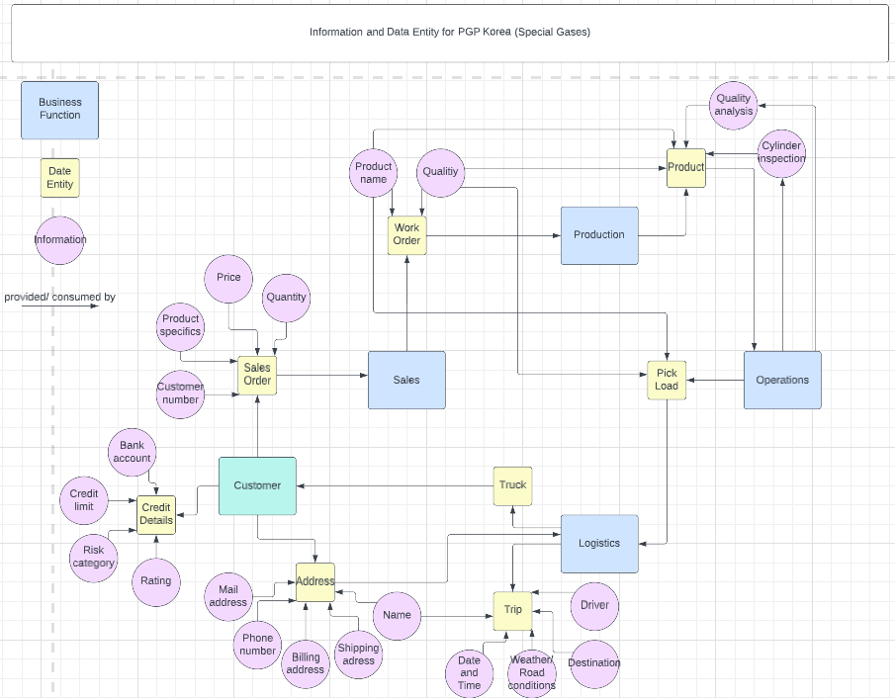

Figure 15: Information map with data entities and business functions - PGP Korea (own illustration)

#### Resources – Applications (Korea)

For successful execution, a BC relies on different types of resources. These include IT components such as applications and infrastructure, but also physical assets such as vehicles, machines and buildings, as well as intangible assets such as intellectual property. (The Open Group 2022d, p. 8) As this thesis is written with the support of the corporate IT of Linde plc, a focus is placed on IT resources, the applications.

The visualisation used for the application view in figure 16 is an application landscape diagram. This type of diagram is already used in a modified form within Linde plc for similar purposes. The concept is based on the artefact application/business function matrix. This is an illustration of which applications are used within each business function. This allows an understanding of the business requirements for application support to be determined. It also supports the practice of a gap analysis and reflects the as-is information system architecture of the enterprise. (The Open Group 2022m, p. 22)

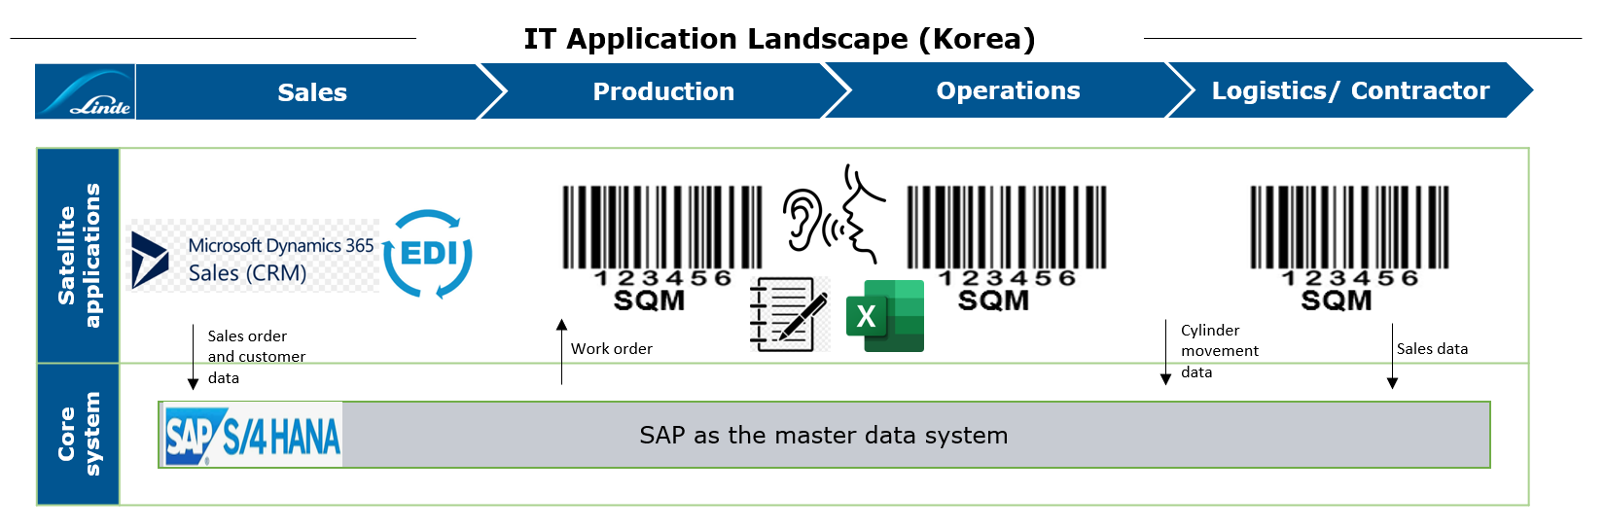

Figure 16: Application landscape diagram - PGP Korea

The entire application landscape relevant for the BC Deliver Product is shown in this diagram. For the PGP Korea BU, it is limited to a very few applications. The core system in Korea is the ERP system SAP S/4 Hana. The Linde-specific and configured template used in Korea is the first in the entire organisation that is based on the new SAP fourth generation system S/4 Hana. The tasks of the SAP system are to provide the deliver processes with the necessary data and to receive it again. (SAP 2023, p. 1) This creates an interplay of data exchange, which is shown in diagram XY (information).

There are two different approaches for ordering gas in Korea. Most Korean customers, who only purchase gas in small quantities, order through the CRM system of Microsoft Dynamics 365. The CRM system is a special sales module of the Microsoft Dynamics ERP system. It is mainly used for managing customer relationships as well as entering customer orders. (Microsoft 2023, p. 1) The eight largest customers, who account for the vast majority of orders, place their orders via a special set-up electronic data interchange (EDI). A so-called EDI interface enables the exchange of electronic commercial documents. The Linde SAP system and the customer's system are linked via the interface. This allows the customer to place a purchase order based on his own inventory data in real time without manual intervention. (IBM 2023, pp. 2) Only one system, SQM, is used for the business functions production, operations, and logistics. This covers the most parts of the supply chain process, starting with the production and analysis of gases, through the management of the gas inventory, to delivery and order fulfilment. Apart from that, a lot of information is passed on verbally, as in scheduling, or information is documented using pen and paper or Excel. (Linde plc 2021c, pp. 6)

#### Resources – Technology (Korea)

However, the resources dimension does not solely focus on applications. Other resources as mentioned, such as machines or the vehicle fleet, are also subject to consideration. The artefact technology portfolio catalogue in table 5 can be modified from its original idea. Instead of typical IT hardware architecture elements the catalogue can be used and extended for resources of technical nature in general (The Open Group 2022m, p. 25). For example, it would be possible to document which vehicles are used for delivery. In Korea, trucks from Hyundai, a car manufacturer also headquartered in the Korea (Hyundai Motor Group 2023, p. 1), are primarily used. The handhelds are used as personal digital assistants (PDA). Depending on the device, it has different functions. In Korea, the handhelds are only needed to scan cylinders in order to register them in SQM and SAP (e.g., full cylinder, empty cylinder, cylinder delivered). In addition to the regular SQM PDA, the specialized ECOM is also used. It is especially safe and must be utilized in special danger zones, for example, in the production area when handling highly inflammable gases. Furthermore, a special barcode printer, Zebra ZM 400, is used to print labels for cylinders. Not only Linde's own barcodes are generated for the cylinders, but also directly customer-specific ones, so that the customers can also account for the cylinders in their systems. For the quality analysis of the gases, a machine called Gas Quality Analyzer is in operation. (Linde plc 2021b, pp. 14–16)

Table 5: Technology portfolio catalogue - PGP Korea

|  |  |  |  |
| --- | --- | --- | --- |
| **Name** | **Type** | **Description** | **Country** |
| Hyundai HD170 | Vehicle | Cylinder truck | Korea |
| Hyundai EX Series | Vehicle | Cylinder truck | Korea |
| SQM PDA | Handheld | Handheld for scanning cylinders | Korea |
| ECOM | Handheld | Intrinsically safe device for danger zones | Global |
| Zebra ZM 400 | Barcode Printer | Printing barcodes for cylinders | Korea |
| Gas Quality Analyzer | Machine | Analysing quality and purity of gas | Korea |

#### Other (Korea)

Not directly related to any of the four dimensions of process, roles, information, or resources, the TOGAF artefacts can also be applied to related areas. Various contracts and service level agreements are signed to manage the contractor. These can be recorded in a contract measure catalogue in table 6. This artefact is an example that the TOGAF framework can be applied to the whole EA and that a BC does not have to be limited to the four components process, role, information and resource. (The Open Group 2022d, p. 13)

The two contracts mentioned here are not further verified. However, it can be assumed that such or similar contracts exist between PGP Korea and the external contractor. It might be agreed how many vehicles the partner must provide for the deliveries and how often they may be out of service at most. Similarly, there could be a contract that states how many of the assigned trips have to be executed. (Anon 2023c)

Table 6: Contract measure catalogue - PGP Korea

|  |  |  |  |
| --- | --- | --- | --- |
| **Business Service** | **Contract** | **Measure** | **Capability** |
| Logistics | Provide and maintain trucks | XY trucks with XY% availability | Fleet Maintenance |
| Logistics | Deliver product | Fulfil XY% of assigned trips | Delivery Execution |

### 6.2.3 Execution of Deliver Product in Germany

The analysis of the Deliver Product BC proceeds according to the exact same procedure as the analysis in Korea from chapter 6.2.2.

#### General Information (Germany)

The analysis of the "Deliver Product" BC in Germany begins with an overview of general information as well. Table 7 contains the following key facts. PGP Germany has 715 employees (Anon 2023d) who account for nearly 500 million euros yearly (Anon 2023g). The precise number of customers cannot be clearly determined in Germany. The reason is that PGP Germany does not only supply typical PGP customers, but occasionally also customers of other business units, such as Onsite & Bulk Germany (OBG). However, it can be said that at the time of writing, cylinders were placed at 135,000 customers sites. In total, 2.3 million cylinders are owned and the number of cylinders sold is at least 3.9 million per year. Here, similarly, the exact number cannot be quantified with certainty. This is due to the fact that the products sold are reported in "containers". A container can correspond to both a cylinder and a bundle, which is standardized packaging size consisting of 12 individual cylinders. In Germany, a wide range of products is offered. This includes industrial gases (IG), technical gases, medical gases and SG, all sold at different price ranges. The most sold product IG is usually cheap to buy. A cylinder can be purchased for starting as low as 10€. With these products, Linde does not earn the money through the gas, but with the package, the actual cylinder. A rental fee is charged for this. Every day that the cylinder is at the customer's site, 0.25€ is charged[4]. Thus, PGP Germany earns more on the rental of the cylinder bottles than on the content, the gas. Additionally, there are also high-priced SG in Germany, such as Xenon, for which a price of up to 500,000€ can be charged. In conclusion, the business is very diverse. Therefore, it is not useful for the BC analysis to consider the PGP business in Germany as a single entity. The results of the analysis are much more informative if a separate documentation is created for SG and IG each. This approach is hence applied in the following. (Anon 2023f)

Table 7: General information about PGP Germany

|  |  |
| --- | --- |
| **PGP Germany** | |
| Employees PGP Germany in FTE | 715 |
| Revenue of PGP Germany in million Euros | 463 |
| PGP customers | 135,000 |
| Own cylinders | 2,300,000 |
| Sold cylinders per year | 3,900,000 containers (bundles or cylinders) |
| Price of products | Wide range of inexpensive and expensive gas products from 10€ to 500,000€ |
| Main products | IG, technical gases, medical gases, SG, electronic gases |

#### Process (Germany – SG)

For the analysis of the process component, the same artefacts are taken as for the analysis in Korea, the Process Flow Diagram designed with icon symbols and the Process/Event/ Control/Product catalogue. Due to the consideration of the different products SG and IG, two artefacts each have to be instantiated accordingly. The first analysis with figure 17 and table 8 refer to SG, the second analysis with figure 18 and table 9 refer to IG.

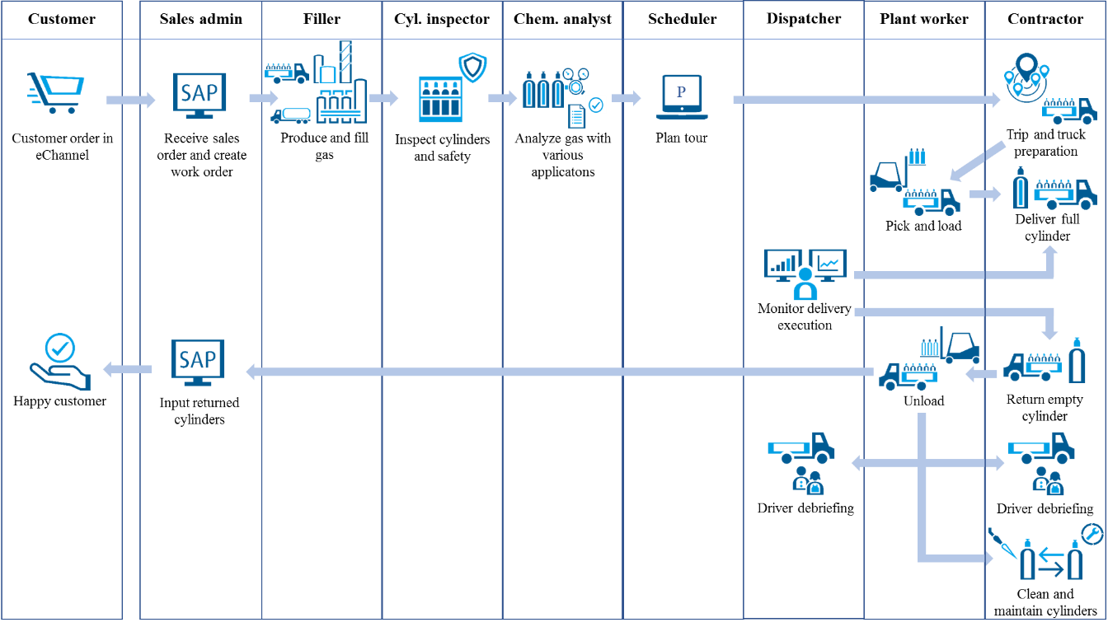

Figure 17: Process flow diagram - PGP Germany (SG) (own illustration)

The process of Deliver Product at PGP Germany SG starts with the income of a specific customer order including a precise description of the demanded gas product in Linde's own e-commerce system called eChannel. From there, the sales order is automatically forwarded to the SAP ERP system. This is then used to create a work order, which informs the respective departments about the order. The production process is started on this premise. The gas is produced and filled into a cylinder. A visual inspection is carried out to identify any external damage to the cylinder that may have occurred during filling. This is followed by a quality check of the gas in form of an analysis. The results of the analysis are entered in one of six gas analysis applications. If the sample is without objections, a CoA is issued as confirmation to the customer. Simultaneously to the gas production, a schedule order is created in the Paragon planning system based on the work order in SAP. The shipment to the customer is scheduled here. For SG in Germany, there are two types of shipping: direct shipping to the customer and internal plant-to-plant shipping. The latter corresponds to 90% of initial product shipments. Only 10% of cylinders are shipped directly to the customer. This is because SG generally must be used directly and cannot be stored. There are strict regulatory requirements for storage, which means that the storable quantity is capped. Typical gas customers cannot meet these requirements. Therefore, most gases are shipped from the SG filling plant to another Linde plant, where they are then safely stored. In both cases, a scheduler checks what needs to be done and where and when the goods are needed and plans a route. For the deliveries, an external transport company steps in. They receive the planned tours from Linde. This way, they know which products must be delivered to the customer and when. Their task is to provide and assign an external driver and an external vehicle, which is not owned by Linde, for these trips as well. The initial “tour” planned by an internal Linde employee is now referred to as a “trip” after being processed and planned by the transport contractor. This way, confusion is avoided by the different choice of wording. After the trip is planned, the corresponding cylinders are taken from the storage and loaded onto the truck. During this process, the cylinders are scanned with a Zebra handheld. The application used is called Lima and records the cylinder movements. As a result, the system registers that the cylinders are no longer available for further sale. The Lima application is used for all cylinder scan processes within the Linde plant on Linde's own grounds. When the driver takes the loaded truck to the customer and unloads the cylinders, they have to be scanned again. Since this event takes place locally at the customer's site and therefore not on Linde's property, a different application called Inlabel must be utilized for scanning the cylinders. It is also installed on the Zebra handhelds and has identical functionalities. The driver loads the empty cylinders and after returning to Linde territory, Lima is used again for scanning during unloading. Before the deliver product process is finally completed, there is one more step for PGP Germany. The ride to the customer and the delivery execution is monitored and tracked. Based on factors such as driving behaviour and adherence to traffic and safety rules, a driving score is generated for the driver from several key performance indicators (KPI). A driver debriefing takes place at regular intervals and sometimes even after each trip. The driver is asked whether there were any problems with the route or the delivery, or whether there have been any modifications on the customer's side, such as a change of contact person. As the very last step, the cylinders are thoroughly cleaned, repaired if necessary, and made reusable by replacing broken parts.

Table 8: Process / Event / Product catalogue - PGP Germany (SG)

|  |  |  |  |
| --- | --- | --- | --- |
| **Process** | **Event (Input)** | **Product (Outcome)** | **Capability** |
| Receive customer in eChannel | Customer action | New customer order captured in eChannel | Sales & Operation Planning |
| Send order and customer data to SAP | Receive order automatically from eChannel | New sales order captured in SAP | Sales & Operation Planning |
| Create work order in SAP | Sales order in SAP | New work order entry | Sales & Operation Planning |
| Produce gas | Production order in SAP | Produced gas | Cylinder Filling |
| Fill gas | Gas produced | Filled gas cylinder | Cylinder Filling |
| Cylinder inspection | Gas filled | Inspected cylinder | Cylinder & Accessory Maintenance |
| Analyse gas | Gas filled | Certificate of Analysis (CoA) | Cylinder Filling |
| Input analyse data in various tools | Gas analysed | Analyse data in tools | Cylinder Filling |
| Work order import to Paragon | Work order in SAP | New work order in Paragon | Scheduling |
| Plan tour | Work order in Paragon | Tour planned | Scheduling |
| Shipping to the neighbouring plant (90%) | Planned tour | Tour planned to plant | Delivery Execution |
| Trip & truck preparation (10%) | Planned tour | Trip planned to customer | Fleet Maintenance |
| Cylinder picking & loading using Inlabel to scan cylinders | Trip completely planned | Loaded truck | Picking & Loading |
| Deliver full cylinders and unload them using Lima | Loaded truck | Delivery fulfilled | Delivery Execution |
| Load empty cylinders at customer's site to return them using Lima | Full cylinders delivered | Empty cylinders loaded to return | Delivery Execution |
| Unload empty cylinders at Linde's site using Inlabel | Empty cylinders loaded | Truck unloaded | Picking & Loading |
| Monitor delivery execution and KPI management for creating driving score | Trip fulfilled | Delivery Execution monitored | Delivery Execution |
| Driver debriefing | Delivery execution monitored | Driver debriefed | Delivery Execution |
| Maintain and clean returned cylinders | Empty cylinders unloaded | Cylinder reusable again | Cylinder & Accessory Maintenance |

(Linde plc 2018c, pp. 9–15) & (Linde plc 2018d, pp. 26–29)

#### Process (Germany – IG)

After completing the process analysis of the SG, the process analysis of the IG is now carried out.

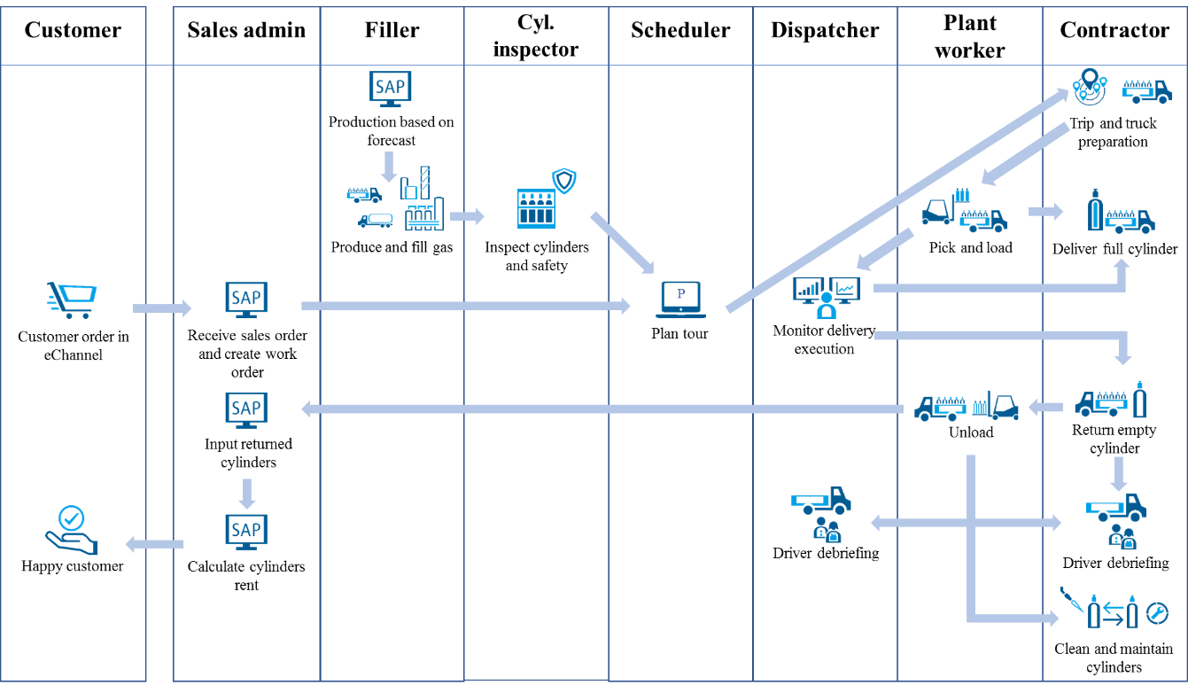

Figure 18: Process flow diagram - PGP Germany (IG) (own illustration)

The Deliver Product process in the production of IG at PGP Germany starts instantly with the production and filling of gas. Forecasts from recent years are used here as the foundation. IG are also referred to as standard gases and are easy to plan due to the recurring orders. After filling, the cylinders are visually inspected and are then ready for sale. In parallel, Linde receives the customer's order via the eChannel system. Here, the customer selects his standard IG from the product catalogue. The sales order is then manually entered into SAP, where a work order is directly generated in the route planning system Paragon for scheduling the delivery. Part of the scheduling process is to first compare the customer's purchase order with the gas stock inventory. If the desired product is not available in the filling plant's stock, a so-called plant-to-plant delivery must be triggered. In this case, the desired product is delivered by a filling plant from another region in Germany. If the ordered gas is available, a tour is planned. To execute the tour, the fleet is prepared and checked for roadworthiness, a driver and a vehicle are assigned to the tour, and a precise delivery time is set. After this step, it is no longer called a "tour" but a "trip". When the trip is fully planned, the cylinders are loaded onto the truck. The Inlabel application is used to scan the cylinder movements at this point. The loaded truck drives to the customer and there, using Lima, the full cylinders are unloaded, and the empty ones are loaded for return. Back at the Linde filling plant, the empty cylinders are unloaded again and scanned with Inlabel. After the trip, a driving score is generated, and the driver is debriefed based on his driving behaviour. After the return of the empty cylinders, the rent for the time the cylinder was at the customer's site is calculated based on the daily rates described in the introduction.

Table 9: Process / Event / Product catalogue - PGP Germany (IG)

|  |  |  |  |
| --- | --- | --- | --- |
| **Process** | **Event (Input)** | **Product (Outcome)** | **Capability** |
| Produce gas | Prior-year forecast | Produced gas | Cylinder Filling |
| Fill gas | Gas produced | Filled gas cylinder | Cylinder Filling |
| Cylinder inspection | Gas filled | Inspected cylinder | Cylinder & Accessory Maintenance |
| Create sales order in SAP | Receive customer order in eChannel | New sales order captured | Sales & Operation Planning |
| Create work order in SAP | Sales order in SAP | New work order entry | Sales & Operation Planning |
| Work order import to Paragon | Work order in SAP | New work order in Paragon | Scheduling |
| Check inventory | Work order in Paragon | Inventory checked | Scheduling |
| Trigger plant-2-plant delivery | Inventory checked | Product provided | Scheduling |
| Plan tour | Inventory checked | Tour planned | Scheduling |
| Trip & truck preparation | Planned tour | Trip & truck prepared | Fleet Maintenance |
| Assigning truck and driver | Trip and truck prepared | Truck, driver and time assigned to trip | Scheduling |
| Cylinder picking & loading using Inlabel to scan cylinders | Trip completely planned | Loaded truck | Picking & Loading |
| Deliver full cylinders and unload them using Lima at customer's site | Loaded truck | Delivery fulfilled | Delivery Execution |
| Load empty cylinders at customer's site to return them using Lima | Full cylinders delivered | Empty cylinders loaded to return | Delivery Execution |
| Unload empty cylinders at Linde's site using Inlabel | Empty cylinders loaded | Truck unloaded | Picking & Loading |
| Monitor delivery execution and KPI management for creating driving score | Trip fulfilled | Delivery execution monitored | Delivery Execution |
| Driver debriefing | Delivery execution monitored | Driver debriefed | Delivery Execution |
| Rent calculation | Empty cylinders unloaded | Rent calculated | Sales & Operation Planning |
| Maintain and clean returned cylinders | Empty cylinders unloaded | Cylinder reusable again | Cylinder & Accessory Maintenance |

(Linde plc 2022b, pp. 3)

#### Roles (Germany – SG & IG)

The following illustrates the role dimension of the Deliver Product capability for PGP Germany. The roles and actors of IG and SG are shown together in a RACI matrix in table 10. Any roles and actors that only occur in one of the two product categories are marked accordingly in the matrix. A written formulation is not provided in this case since the roles and actors are already known from the previous analysis. In addition, the reader is familiar with the RACI matrix and can derive the information directly out of it. Only new observations will be discussed in the following.

General

When executing the capability Deliver Product, the plant manager is accountable for each role and actor that is occupied or executed by an internal employee. He is therefore accountable as a manager for the entire filling plant.

Deliver Product

New roles are formed when the Deliver Product capability is exercised in Germany. Here, for the first time, a dispatcher acts as the responsible actor. He is dealing with the trip plan communication with the drivers of the external contractor. In addition, he also monitors the driving behaviour and conducts a driver debriefing together with them.

Cylinder & Accessory Maintenance

The maintenance of cylinders and other accessories is carried out by an external partner. After the cylinders have been used, they are dispatched to the partner, who operates his cleaning facilities at its own site. There, the cylinders are cleaned, maintained and, if necessary, repaired or replaced.

Supply Chain Management

A special function in Germany and the entire Europe, Middle East and Africa (EMEA) region has the Centre of Competence (CoC). The CoC supervises, improves, and standardizes all sub-capabilities involved in the level-1 supply chain management capability across all countries. The aim is to define global best practices. For this reason, they provide reciprocal consulting support for all roles of the Deliver Product capability.

Table 10: RACI matrix - PGP Germany

|  |
| --- |
| **Deliver Product - PGP Germany** |

|  |  |  |  |  |  |  |  |  |  |  |  |
| --- | --- | --- | --- | --- | --- | --- | --- | --- | --- | --- | --- |
|  | **Plant manager** | **Sales admin** | **Filler** | **Cylinder inspector** | **Chemical analyst (SG)** | **Scheduler** | **Dispatcher** | **Plant worker** | **External contractor** | **Centre of Competence** | |
| Sales & Operation Planning | | | | | | | | | | |
| * Manage customers | A | R | - | - | - | - | - | - | - | C | |
| * Manage sales orders | A | R | - | - | - | - | - | - | - | C | |
| * Manage work orders | A | R | I | I | **I** | I | I | I | I | C | |
| * Calculate cylinder rent (IG) | A | R | - | - | - | - | - | - | - | C | |
| Cylinder Filling | | | | | | | | | | |
| * Produce gas | A | - | R | I | I | - | - | - | - | C | |
| * Fill gas | A | - | R | I | I | - | - | I | - | C | |
| * Analyse gas (SG) | A | - | I | - | R | - | - | - | - | C | |
| Cylinder & Accessory Maintenance | | | | | | | | | | |
| * Inspect cylinders (SG) | A | - | I | R | - | I | - | - | - | C | |
| * Inspect cylinders (IG) | A | - | I | R | - | - | - | - | - | C | |
| * Manage inventory | A | R | - | - | - | - | - | - | I | C | |
| * Maintain cylinders | - | - | - | I | - | - | - | - | R | C | |
| Fleet Maintenance | | | | | | | | | | |
| * Contract management | R | - | - | - | - | - | C | I | R | C | |
| * Prepare truck | - | - | - | - | - | I | I | I | R | C | |
| Scheduling | | | | | | | | | | |
| * Schedule tour | A | - | - | - | - | R | I | I | I | C | |
| * IG: Trigger plan-to-plant delivery | A | - | - | - | - | R | I | - | - | C | |
| * Schedule trip | - | - | - | - | - | C | I | I | R | C | |
| Picking & Loading | | | | | | | | | | |
| * Pick & load cylinders | A | - | - | - | - | - | I | R | I | C | |
| Delivery Execution | | | | | | | | | | |
| * Deliver cylinder | - | I | - | - | - | I | I | - | R | C | |
| * Return cylinder | - | I | - | I | - | - | I | I | R | C | |
| * Communicate trip plan | A | - | - | - | - | - | R | - | I | C | |
| * Monitor delivery execution | A | - | - | - | - | - | R | - | I | C | |
| * Debrief driver | A | - | - | - | - | - | R | - | I | C | |
| Supply Chain Management | | | | | | | | | | |
| * Enhance Supply-Chain processes | C | C | C | C | C | C | C | C | C | R | |

(Linde plc 2018d, pp. 26–29)

#### Information (Germany – SG & IG)

The analysis of the information component at PGP Germany showed a very similar result to the analysis at PGP Korea. For the presentation of the XXX, the SG refers to figure XY in chapter 6.2.2.

The representation for IG is minimally modified and is presented below in figure XY. The changes are limited to a different information of the data entity sales order. A material number is required for IGs, as these are standard gases that only have to be selected from a catalogue. Besides, the information for the gas analysis is omitted for the product data entity. (Linde plc 2018b, p. 1)

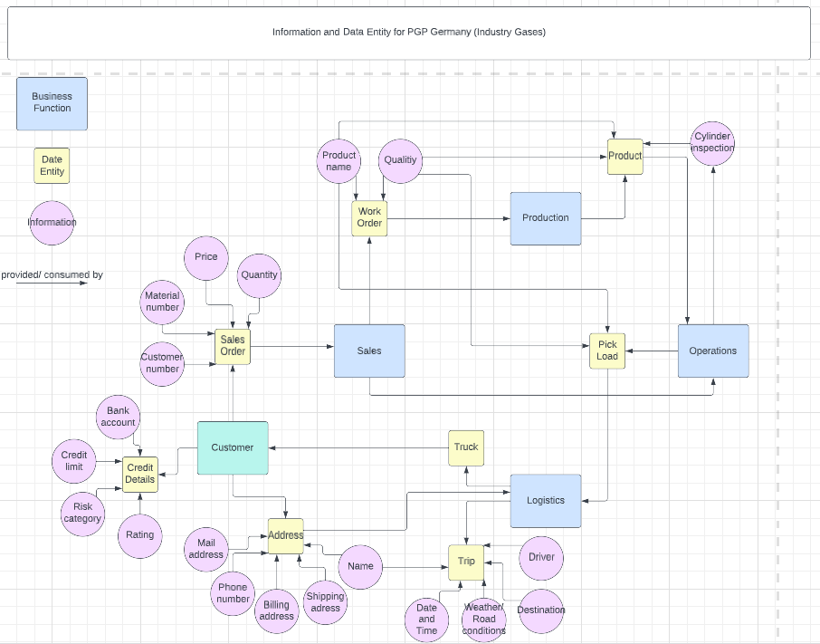

Figure 19: Information map with data entities and business functions - PGP Germany (own illustration)

#### Resources – Applications (SG & IG)

The applications used at SG and IG can be described together as they are equally applied in both cases.

The ERP system used in Germany is the meanwhile outdated SAP ECC system. As part of a large SAP project at Linde, the system is to be replaced in the future by SAP S/4 Hana.

For entering the customer order, the e-commerce system eChannel is used. It makes no difference whether the customer requests a self-defined gas mixture or simply selects standard IG from Linde's product catalogue.

The production orders are read directly from SAP. No other systems are required here. Various analysis applications are only used for the gas analysis of the SG.

In the operational area, Paragon is used for route and delivery planning.

When loading and unloading the truck, the cylinders are scanned to record their movement data and keep the stock inventory data accurate. The Inlabel application is used inside Linde's own facilities and the Lima application is used outside Linde's facilities, for example at the customer's site.

The company TomTom specializes in navigation technology and applications and offers a wide range of products and services for fleet management efficiency. The same-named software TomTom used by Linde is implemented as a GPS tracking and locating system for monitoring and supervising drivers. Webfleet, also an application from the TomTom portfolio is a fleet management solution, which helps to manage the fleet effectively. At Linde, the system is used to document and evaluate driver movements and driving behaviour. This includes monitoring working hours and adherence to breaks, as well as observing safety rules, traffic regulations and anticipatory driving. (Linde plc 2022a, p. 4) & (Linde plc 2019, pp. 2–17)

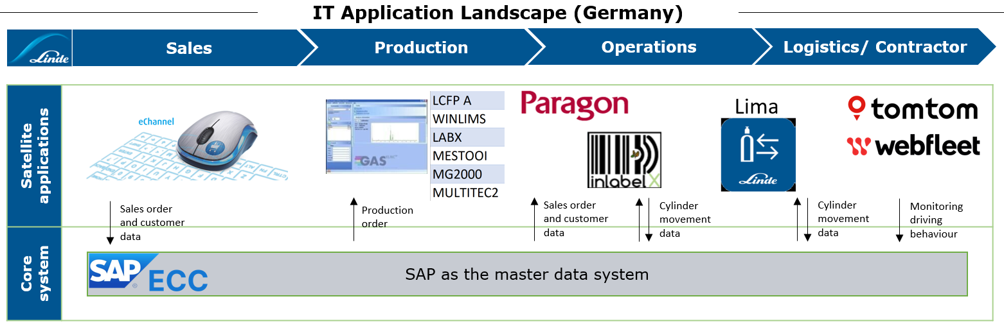

Figure 20: Application landscape diagram - PGP Germany (own illustration)

#### Resources – Technology (SG & IG)

The deployed resources discovered for PGP Germany are limited to fleet and handhelds, which are used jointly for SG and IG. The vehicles in use at Linde are from the Swedish manufacturer Scania and the Japanese company Mitsubishi Fuso, which, however, is largely owned by the German company Daimler Trucks. The handheld used is the Zebra handheld. It is an Android touch computer which is characterized by its robustness and can therefore be operated in production facilities and similar environments. It is especially used for mobile data collection and scanning cylinders. (Linde plc 2019, pp. 2–17) & (Linde plc 2020, p. 5)

Table 11: Technology portfolio catalogue - PGP Germany

|  |  |  |  |
| --- | --- | --- | --- |
| **Name** | **Type** | **Description** | **Country** |
| Scania B400 | Vehicle | Cylinder truck | Germany |
| Fuso Canter 7.5t | Vehicle | Cylinder truck | Germany |
| Zebra TC25/26/56/57 | Handheld | Handheld for Scanning Cylinder | Global |
| ECOM | Handheld | Intrinsically safe device for danger zones | Global |

#### Other (SG & IG)

Other aspects of enterprise architecture not covered by TOGAF BC components include contracts with external partners. The contracts listed here are fictional but could exist in this or a similar form. PGP Germany could have contracts for the deployment of external vehicles, the completion of assigned trips, and the maintenance and cleaning of cylinders and other accessories.

Table 12: Contract measure catalogue - PGP Germany

|  |  |  |  |
| --- | --- | --- | --- |
| **Business Service** | **Contract** | **Measure** | **Capability** |
| Logistics | Provide and maintain trucks | AB% truck availability | Fleet Maintenance |
| Logistics | Deliver product | Fulfil AB% of assigned deliveries | Delivery Execution |
| Production | Maintain cylinders | AB | Cylinder & Accessory Maintenance |

(Linde plc 2014, pp. 2–8)

### 6.2.4 Comparison of Korea and Germany and its emerging hypotheses

After examining Deliver Product BC in Korea and Germany, the results of the analysis in Korea and Germany compared. The aim is to find out what conclusions can be drawn about the similarities but also the differences in the execution of the BC. For this purpose, XY hypotheses are presented below based on the developed artefacts in chapter XY. In order to confirm the derived hypotheses, a semi-structured expert interview was conducted with two experienced Linde managers, referred to as P2 and P3 in the attached interview transcript. P2 has worked at Linde for 11 years and started as an enterprise architect. Today, he is Director of Architecture & Design. P3 has been with Linde for almost 23 years and has the role of Associate Director Functional Consulting Supply. He possesses a deep knowledge in the area of supply chain management. Both work in corporate IT and are familiar with the BC Deliver Product in Korea and Germany. (QUELLE: Interview) and follow-up conversation per Mail??

Kommentar: Scale of Korea and Germany

|  |  |
| --- | --- |
| **Hypothesis 1 - Variances in the process flows are gas product-specific than country-specific indicating high standardization potential.** | |
| Why | The Deliver Product process of IG is different than the production of SG. |
| Details | Based on the comparison of the process component illustrated in figure 13, 17 and 18 in combination with table 3, 8 and 9, it is noticeable that the Deliver Product processes are very similar, especially when comparing the SG. Larger discrepancies can be identified in comparison with the IG in Germany. While IG are produced on the basis of annual forecasts (make-to-stock), a specific customer order must first be received so that the SG can be produced and compounded according to the customer's request (make-to-order). In addition, there are process steps that only exist at SG and not at IG, such as the quality analysis of the gas mixture. |
| Expert statement | Confirmed. (Seite 1) |
| **Hypothesis 2 - The scale of the operation is influencing the organizational structure and therefore standardization differs throughout business growth; BC management can streamline this process**  **assignment of actors to the roles depends on the size of the BU.**  **Skalierung der BC wird gestreamlined.**  **BC could support the Korean business in streamlining the business growth evolution.**  **(Prozess, tool automatization,…)** | |
| Why | An actor in Korea is responsible for more roles than an actor in Germany. |
| Details | In Korea, significantly more roles are performed by the same actor (see table 4). For example, the filler supervisor takes care of supervising the gas production and the filling of the cylinders. At the same time, he also takes on the role of cylinder inspection. In Germany, the schedule processes are also divided between the scheduler, the dispatcher, and the external contractor (see table 10). In Korea, there is only one scheduler. In Korea, the plant worker is responsible for picking and loading the cylinders, but also for maintaining the hardgoods. In Germany, these tasks are divided between the plant worker and an external contractor. This is a logical conclusion based on the different sizes of the BUs. |
| Expert statement | Confirmed. (Seite 3) |
| **Hypothesis 3 - Although there are differences in role staffing for different products, it should be examined in combination. (Raushauen?)**  **Rollen standardisieren und outsourcen** | |
| Why | Synergies in filling roles could be identified across the product range of SG and IG. |
| Details | The filling of roles by actors in Germany shows that certain roles at both SG and IG are performed by an external partner. This is the case with the cylinder technician and the driver in (see table 10). Although the production and filling of SG and IG takes place in separate, independent filling plants, the joint consideration of actors can be a source of synergies. |
| Expert Statement | Confirmed. (Seite 3) |
| **Hypothesis 4 - The type of information required seem to be identical across countries which indicates that applications can be standardized.** | |
| Why | The information diagrams appear identical, with minor exceptions. |
| Details | There are only marginal differences in the order composition of IG and SG (specific requirements/ standard catalogue product) and in the analysis of SG, as indicated in the information maps presented in figure 15 and figure 19. |
| Expert statement | Disproved. At the level examined, this conclusion is correct. However, by studying the details of the required information, differences will be found that could not be revealed in this analysis. A more extensive analysis is necessary to determine the exact differences and their degree of deviation. (Page 8) |
| **Hypothesis 5 - The Deliver Product processes could be standardized even more across different countries.**  **Higher standardization level could be reached**  **Abwägung Governance model vs. benefit streamline** | |
| Why | The processes are nearly the same in Korea and Germany when the same kind of product is delivered. |
| Details | As stated, and confirmed in hypothesis 1, the processes are almost identical. It seems that the process in Germany is a bit more complex. This is due to the fact that, for example, the shipping of highly explosive SG in Germany is subject to more stringent safety requirements and regulations. Instead of the SG being delivered directly to the customer, in Germany it has to be checked whether it can be delivered directly, and the customer uses it immediately, or whether the gas has to be temporarily stored in an appropriate Linde gas storage depot first. Furthermore, the Deliver Product process appears to be slightly different in the intermediate picking and loading steps in Germany than in Korea. However, this impression is rather misleading. In the case of the German product delivery, only the use of two different applications is shown in finer detail. The only real difference in the process is the monitoring of the product delivery, the creation of a driving score based on KPIs and the driver debriefing. However, this is not a core step in the Deliver Product process. |
| Expert statement | Confirmed. The processes in Korea and Germany are already standardised to a certain extent. The limiting factor is the size of the two companies and the country-specific legal regulations. However, if PGP Korea increases their economies of scale, then a BC analysis can deduce whether further standardisation of processes is possible and necessary. (page 2) |
| **Hypothesis 6 - A further increase in standardisation may not be practical due to country-specific regulations and societal characteristics.** | |
| Why | Based on the role and actor analysis, there is a greater focus on safety in Germany. In Korea, hierarchical structures are more prevalent. |
| Details | This statement can be founded in particular on the basis of the RACI matrices in table 4 and table 10 with focus on the actor filler supervisor. Although the same SG is produced and filled in Korea and Germany, this actor exists only in Korea. This is because the regular filler in Germany is highly qualified and an expert in chemicals and gases. The fillers are trained well enough to do the job independently. In Korea, on the other hand, the fillers are less trained. They perform the same dangerous activities with lower qualification. Therefore, a filler supervisor is needed. This proves that in a country such as Germany, there are stricter working conditions and better protections through regulatory. In Korea, on the other hand, there is a stronger hierarchical thinking. In addition, the working conditions there are significantly worse.  This is also evidenced by the additional roles in the delivery of products. In Germany, there is additional monitoring of driving safety and compliance with traffic rules of the driver. Afterwards, an interview is also conducted, and a performance- and safety-related score is issued. This procedure is not conducted in Korea. |
| Expert statement | Confirmed. However, it is differentiated that the role of the filler supervisor in Korea does not indicate lower safety standards, but rather a different way of enforcing them based on the size of the business and the social background of the country. Nevertheless, attention must be paid to country-specific circumstances. (Seite 2) |
| **Hypothesis 7 - The same handheld barcode scanning model could be used across countries.**  **Mit BC dokumentiert, Leichter zu bewerten ob es geht oder nicht** | |
| Why | The hardware is of no relevance for the installed software applications. |
| Details | As listed in table 5 and table 11, the Ecom handheld is already in use in Korea and Germany. Accordingly, it should also be technically possible to install the software installed on the Korean SQM PDA on the Zebra devices. Zebra handhelds are used in over 50 countries. The next time Korea switches to the new generation of handhelds, it should also use Zebra. With a global team providing support for Zebra handhelds, costs can be saved. |
| Expert statement | Confirmed. There is a high probability that the next generation of handhelds will be aligned with the global standard. Seite 6-7 |
| **Hypothesis 8 – Commodities have been identified where standardisation might not be worth the effort.** | |
| Why | The commodities reflect local requirements and the costs of standardisation do not correspond to the benefits achieved. |
| Details | The potential for improvement or synergy effects through standardising resources or commodities such as barcode scanners is probably too little (see table 5 and table 11). The fact that a Korean manufacturer is chosen for vehicles in Korea and a European manufacturer in Germany can be explained by local requirements such as trust and home-bias. Possibly, neighbouring countries and regions could combine in procurement to create possible synergy effects. |
| Expert statement | Confirmed. (Seite 7) |
| **Hypothesis 9 – There is standardization potential across countries.** | |
| Why | The processes are very similar and some of the applications used in Germany are already being deployed globally. |
| Details | Although the processes are very similar, as confirmed in hypothesis 5, there is no overlap in the use of the applications (see figure 16 and figure 20). Solely, the ERP system in both countries is from SAP, even though different versions and templates are used. The eChannel system in Germany is used to collect customer orders. It is already used globally in over 40 countries. Korea, on the other hand, uses MS D365 CRM as well as EDI interfaces. Since they have less than 300 customers using this system, switching to eChannel has never been worthwhile. The same applies to Paragon, which is also implemented in over 25 countries. Again, it's not worth it in Korea, because they only have a limited number of drivers, and they know the routes to the customer and don't need more detailed planning. Here, too, the implementation effort for the application would be too extensive to do justice to the possible benefits such as paperless working and secure documentation. A variety of different applications are used for gas analysis in Germany. Presumably, all of these could also be used in Korea. However, the business in Korea is forced to use SQM because, as already mentioned, it is specially certified by the largest customer Samsung in order to be able to comply with quality requirements. Therefore, a change is not possible or only possible with difficulty and thus not recommended. However, SQM could replace the analysis tools in Germany. It must be examined whether the number of tools is accompanied by a higher variety of gas supply. Inlabel and Lima are used in Germany to record cylinder movements. Both apps would also work in Korea. However, these functionalities are already covered by SQM. Since SQM cannot be replaced in Korea, it is not worth introducing Inlabel and Lima. Since SQM offers so many functionalities, it could be examined whether SQM, despite the Korean specifications with regard to Samsung's certification, can also be used in Germany and thus replace the two applications Inlabel and Lima. There is a possibility to adapt the application landscape in the last step of the process. If Korea wants to introduce debriefing of drivers, as Germany has already done, they can take their example from Germany. Webfleet could be introduced for these purposes. Most likely, Korea is not interested in a digital debriefing solution, as it is not profitable for the five to ten drivers who are on the road every day. The debriefing can continue to take place verbally. Changing habits is often not easy and not necessary in this case. However, a clear recommendation can be made for the TomTom application. It serves as a GPS system and increases the safety of drivers. In emergency situations, such as accidents or car breakdown, they can be located and recovered directly. The use of the GPS system is worthwhile even from the first vehicle. It also supports one of the most important corporate goals, the zero-incidents strategy at Linde. An implementation of TomTom does not require a high effort either. |
| Expert statement | Confirmed with constraints. (Seite 3-6)  The common use of SAP as an ERP system proves that the differences are not significant enough to prevent a certain degree of standardisation.  Since Korea only has a limited number of customers, the introduction of e-Channel is not required and the mentioned EDI and CRM solutions are sufficient. The same applies for Paragon and Webfleet as the number of trips is limited in Korea. However, that might change in future, when the PGP Korea business continue to grow and a direct communication with the driver is not possible due to a larger scale of operations. Standardisation of gas analysis applications is difficult to implement because SQM is specifically tailored to Korea. Instead of TomTom, the trucks in Korea are equipped with an on-board computer technology tracking them, which obsoletes the need to introduce TomTom. |

Based on the conducted analysis of the BC Deliver Product in Korea and Germany, the established hypotheses and their assessment in form of an expert interview, the following realisations were obtained.

The fundamental BC Deliver Product is to a large extent similar in the execution in both countries. The main differences were identified when the supplied gas varies. (Hypothesis 1) Furthermore, disparities were identified that occur as a result of the dissimilar scaling of the business, thus entailing different business requirements (Hypothesis 5). Consequently, there are differences in the allocation of roles by actors, which can be attributed to the different scaling of the two businesses as well (Hypothesis 2). The information required for the execution of the BC Deliver Product seems to be identical on a superficial level. A deeper analysis might reveal further hidden differences. (Hypothesis 4) Furthermore, it was indicated that country-specific conditions exist, which are demonstrated in the execution of the BC and need to be considered (Hypothesis 6). Despite the anticipated differences, a standardisation of the application landscape seems feasible in the future. This requires that the Korean business scales up to be on a similar footing as the German business. (Hypothesis 9) One object could already be identified for standardisation in the field of common technologies used (Hypothesis 7). When considering standardisation projects, it is important to be aware of local circumstances that could complicate the effort of standardisation and reduce the potential benefits (Hypothesis 8).

In summary, it can be concluded that the Deliver Product execution of the two countries analysed is fundamentally the same. However, there are differences that can be explained by country-specific characteristics and in particular the scale of the businesses. Should Korea, which is the fastest growing PGP unit in terms of revenue in the Linde Group, encounter similar business requirements in the future, it seems recommendable to follow the Deliver Product architecture in Germany.

# 7 Improving Linde’s corporate IT demand process through Business Capability Management

In the previous chapters, the BC methodology was applied in practice using various artefacts based on the EA framework TOGAF. In the following, it is evaluated whether the BC methodology can improve the corporate IT demand process of Linde plc in future.

As presented in chapter 5, the demand team does not follow a stringent approach when deciding on the realisation of demands. The experts of the demand team individually conduct an analysis of the addressed BC. As there is no structured EA method in place at Linde, the experience and professional judgement of the respective experts is relied upon.

In order to assess whether the application of the TOGAF BC method offers added value, it is necessary to take a closer look at the demands that are created.

The requests can be divided into two groups. The vast majority of requests relate to small enhancements. In these cases, the architecture of the company is not substantially changed. However, there are also demands that require large projects. Because Linde does not use a consistent method, the BC components, with a focus on processes, roles, information and resources, have to be examined and analysed each time anew. An understanding or documentation of the BC is not always given.

In the case of enhancements, a detailed BC analysis according to TOGAF is not beneficial. The additional effort required for detailed BC documentation will presumably not create any significant added value. In the case of wide-reaching demands that affect the EA deeply, the application of the TOGAF BC analysis is value-creating. The implementation in chapter 6.2 indicates that the analysis can be used to develop an understanding of the BC under consideration and subsequently provide a basis for decision-making. In the case of Korea and Germany, the BC analysis of Germany can serve as a target architecture for the baseline architecture presented in Korea. Therefore, a careful examination of the BC components should take place in advance of large projects in order to actualise the understanding and documentation and to verify the impact of the demand on the company.

- The largest proportion of requests consists of "small" requests, such as a change to an existing system or the introduction of a new Software-as-a-Service (Saas) solution. Here, only selective background information is required, such as the type of change and the value added through the new functionality of the system. Here it is not possible to give a general answer to the question of whether a BC analysis should be introduced on the basis of the TOGAF artefacts. This question must be decided depending on the situation and can be answered with "no" in most cases. After all, the impact on the EA of Linde plc is only marginal.

- The situation is different when a demand is created that requires a "major" conversion project. This is only the case a few times a year, such as in 2021 when the question arises as to whether and which new ERP system should be introduced in Korea. In the past, an analysis of the BC has been carried out. However, it was not based on a methodology like TOGAF, but on the experience of the business consultants and the IT demand team. For their BC analysis, the IT demand team acquires its own understanding of BC and uses, for example, the application inventory mentioned in chapter XY. However, there is no strict approach so far. As long as the initial situation, i.e. the as-is and to-be architecture in the corresponding BC is clear to all participants, this procedure is tolerable.

Since this is not necessarily the case in many cases, applying the TOGAF BC analysis using the artefacts can offer an advantage at this point. With the help of the artefacts, a gap analysis can be carried out in a way that is understandable for all BC stakeholders and the often limited focus on one's own area can be expanded to a holistic view in the form of the four components. In these cases, a clear recommendation can be made to use the TOGAF BC methodology in order to identify a holistic view of the EA and the levers for eliminating inconsistencies and weaknesses as early as possible.

How? Mandatory documents and training of business consultants

As an industrial group with annual sales of $33 billion in 2022, earnings of $8.7 billion and an EBIT margin of 27%, Linde is well above industry peers. This is partly due to the fact that Linde has its capex under control. The annual $3.2 billion euros investments are extensively planned in the corresponding demand and planning processes and the expenditures are meticulously calculated to optimize costs. (Linde plc 2023a, p. 20) This is necessary because Linde has set itself the goal of increasing profits by up to 12% for the following year (Reuters 2023, p. 2).

Quelle 79, S.43ff

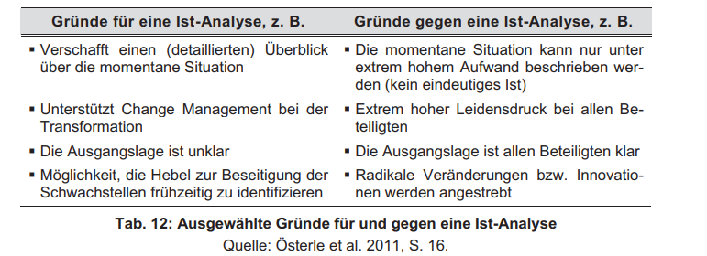S. Quelle 81, S. 162

# 8 Summary

Lorem Ipsum Lorem Ipsum Lorem Ipsum Lorem Ipsum Lorem Ipsum Lorem Ipsum Lorem Ipsum Lorem Ipsum Lorem Ipsum Lorem Ipsum Lorem Ipsum Lorem Ipsum Lorem Ipsum Lorem Ipsum Lorem Ipsum Lorem Ipsum Lorem Ipsum Lorem Ipsum Lorem Ipsum Lorem Ipsum Lorem Ipsum Lorem Ipsum Lorem Ipsum Lorem Ipsum Lorem Ipsum Lorem Ipsum

... In the course of this work, another problem was identified that complicates the work of the IT-DM team. Unfortunately, there is a widely known problem of infomation-hoarding in the company. Due to the company structure mentioned in chapter XY, Linde should be described as international rather than a global company. Each country has its own local supply-chain and thus no reason to document or share its own information in detail.

Bibliography

Abraham, R. (2013): Enterprise Architecture Artifacts as Boundary Objects - A Framework of Properties, Utrecht: Association for Information Systems, Available at https://​www.alexandria.unisg.ch​/​publications/​223501.

Acar, A.; Zehir, C. (2010): The harmonized effects of generic strategies and business capabilities on business performance. In: *Journal of Business Economics and Management* (11), S. 689–711.

Adams, M.; Componation, P.; Czarnecki, H.; Schroer, B. J. (1999): Simulation as a tool for continuous process improvement. In: Simulation Conference Proceedings, 1999 Winter. 1999 Winter Conference on Simulation. Phoenix, AZ, USA, 5-8 Dec. 1999: IEEE / Institute of Electrical and Electronics Engineers Incorporated, S. 766–773.

Alonso, I. A.; Verdún, J. C.; Caro, E. T. (2013): Case Study of Strategic IT Demand Management in Organizations – Exploratory Results. In: *Procedia Technology* (9), S. 900–909.

Anon (2023a): Definition of Deliver Product, Pullach, 1/23/2023, Mail to S. Kuchenbauer.

Anon (2023b): General information to PGP Korea for bachelor thesis, Seoul, 2/22/2023, Mail to S. Kuchenbauer.

Anon (2023c): Deliver Product - Korea, Seoul, 2/24/2023, Mail to S. Kuchenbauer.

Anon (2023d): Mitarbeiterzahlen bei PGP Germany, Pullach, 3/1/2023, MS Teams Message to S. Kuchenbauer.

Anon (2023e): Financial information - PGP Korea, Seoul, 3/6/2023, Mail to S. Kuchenbauer.

Anon (2023f): Zahlen zu PGP Germany für Bachelorarbeit, Pullach, 3/8/2023, Mail to S. Kuchenbauer.

Anon (2023g): Finanzkennzahlen zu PGP Germany, Pullach, 3/13/2023, Mail to S. Kuchenbauer.

Anon (2023h): Beschreibung von On-Site and Bulk, Pullach, 3/31/2023, Mail to S. Kuchenbauer.

Aziz, S.; Obitz, T.; Modi, R.; Sarkar, S. (2005): Enterprise Architecture: A Governance Framework, Bangalore, Available at https://​cioindex.com​/​wp-​content/​uploads/​nm/​articlefiles/​3998-​ea-​governance-​1.pdf.

Barroero, T.; Motta, G.; Pignatelli, G. (2010): Business Capabilities Centric Enterprise Architecture. In: Peter Bernus (Hg.): Enterprise architecture, integration and interoperability, Bd. 326. Berlin: IFIP International Federation for Information Processing (IFIP Advances in Information and Communication Technology, 326), S. 32–43.

Bartenschlager, J.; Goeken, M. (2010): IT strategy Implementation Framework - Bridging Enterprise Architecture and IT Governance, Frankfurt: AMCIS 2010 Proceedings, Available at https://​aisel.aisnet.org​/​amcis2010/​400/​.

BG RCI (2012): Erstickungsgefahr durch Gase: Sicherheitskurzgespräche, Heidelberg: Berufsgenossenschaft Rohstoffe und chemische Industrie, Available at https://​www.bgrci.de​/​fileadmin/​BGRCI/​Downloads/​DL_​Praevention/​Gase_​unter_​Druck__​Microsite_/​SKG/​SKG_​008_​Erstickungsgefahr_​durch_​Gase.pdf, zuletzt geprüft am 4/10/2023.

Bittermann, P. (2017): Linde eröffnet Luftzerlegungsanlage in Eisenhüttenstadt: Industriegase. In: *CHEMIE TECHNIK* 2017, 6/26/2017, Available at https://​www.chemietechnik.de​/​markt/​linde-​eroeffnet-​luftzerlegungsanlage-​in-​eisenhuettenstadt.html, zuletzt geprüft am 4/9/2023.

Bondel, G.; Faber, A.; Matthes, F. (2018): Reporting from the Implementation of a Business Capability Map as Business-IT Alignment Tool. In: 2018 IEEE 22nd International Enterprise Distributed Object Computing Workshop (EDOCW): IEEE, S. 125–134.

Brooks, T. (2009): Enterprise Architecture Governance: A Framework Approach, Austin: Architecture & Governance.

Buckl, S.; Schweda, C. (2011): On the State-of-the-Art in Enterprise Architecture Management Literature.

Bundesministerium der Justiz (2002): Bekanntmachung des "Deutschen Corporate Governance Kodex".

Cambridge Dictionary (2023): Meaning of capability in English, Available at https://​dictionary.cambridge.org​/​dictionary/​english/​capability, zuletzt aktualisiert am 4/6/2023, zuletzt geprüft am 4/6/2023.

Chemie Technik (2019): Linde nimmt Luftzerleger in Röthenbach in Betrieb: Flüssiggase für Metropolregion Nürnberg. In: *CHEMIE TECHNIK* 2019, 5/23/2019, Available at https://​www.chemietechnik.de​/​anlagenbau/​linde-​nimmt-​luftzerleger-​in-​roethenbach-​in-​betrieb.html, zuletzt geprüft am 4/9/2023.

Choi, J.; Lim, S.; Park, S.; Roh, H.; Jin, H.; Lee, C. (2022): The Serious Accidents Punishment Act of South Korea and Its Impact on the Shipping Industry: Toward Sustainability. In: *Sustainability* 14 (14), S. 1–20.

Cook, D. (2007): Business-Capability Mapping: Staying Ahead of the Joneses, Vancouver.

Daud, A.; Latief, F. (2020): Impact Practice Empirical Process Study to Explore the Mechanisms in Architecturally Hierarchical Systems Managing Innovation, Makasar: Center for Open Science.

Davis, R. (2005): Business process modelling with ARIS: A practical guide, 4. Ed., London: Springer.

Dumitriu, D.; Popescu, M. A.-M. (2020): Enterprise Architecture Framework Design in IT Management. In: *Procedia Manufacturing* 46, S. 932–940.

Enstrom, D. (2018): Guideline: Users, Actors and Roles, Available at https://​www.unified-am.com​/​UAM/​UAM/​guidances/​guidelines/​uam_​user-​actor-​role_​8210ACA7.html, zuletzt aktualisiert am 10/15/2018, zuletzt geprüft am 4/10/2023.

European Commission (3/6/2006): Corporate governance: European Forum clarifies 'comply or explain' principle and issues annual report.

Eurostat (2013): Glossary - Business functions, Available at https://​ec.europa.eu​/​eurostat/​statistics-​explained/​index.php​?​title=​Glossary:Business_functions, zuletzt aktualisiert am 9/22/2022, zuletzt geprüft am 4/1/2023.

Fleischer, J.; Herm, M.; Ude, J. (2007): Business Capabilities as configuration elements of value added networks. In: *Prod. Eng. Res. Devel.* 1 (2), S. 187–192, Available at https://​link.springer.com​/​article/​10.1007/​s11740-​007-​0012-​1.

Fröhlich, M. (Hg.) (2007): IT-Governance: Leitfaden für eine praxisgerechte Implementierung, Wiesbaden: Gabler.

Gartner (n.d.): Definition of IT Governance (ITG): Gartner Information Technology Glossary, Available at https://​www.gartner.com​/​en/​information-​technology/​glossary/​it-​governance, zuletzt aktualisiert am 3/22/2023, zuletzt geprüft am 3/22/2023.

Gërvalla, M.; Preniqi, N.; Kopacek, P. (2018): IT Infrastructure Library (ITIL) framework approach to IT Governance. In: *IFAC-PapersOnLine* 51 (30), S. 181–185.

GOV.UK (2012): MOD Architecture Framework, Available at https://​www.gov.uk​/​guidance/​mod-​architecture-​framework, zuletzt aktualisiert am 4/2/2023, zuletzt geprüft am 4/2/2023.

Grant, G.; Collins, R. (2016): The Value Imperative: Harvesting Value from Your IT Initiatives, New York: Palgrave Macmillan US.

Grant, R. M. (1996): Prospering in Dynamically-Competitive Environments: Organizational Capability as Knowledge Integration. In: *Organization Science* 7 (4), S. 375–387.

Graves, T. (2023): Everyday Enterprise Architecture: Sense-making, Strategy, Structures, and Solutions, Eaglehawk: Apress.

Greefhorst, D.; Proper, E. (2011): Architecture Principles: The cornerstones of enterprise architecture, Berlin, Heidelberg: Springer Berlin Heidelberg (4).

Habisch, A.; Neureiter, M.; Schmidpeter, R. (2008): Handbuch Corporate Citizenship: Corporate Social Responsibility für Manager, Berlin, Heidelberg: Springer Berlin Heidelberg.

Helmke, S.; Uebel, M. (2016): Managementorientiertes IT-Controlling und IT-Governance, Wiesbaden: Springer Fachmedien Wiesbaden.

Hyundai Motor Group (2023): Hyundai Motor Company, Seoul, Available at https://​www.hyundaimotorgroup.com​/​group/​CONT0000000000000646, zuletzt aktualisiert am 4/10/2023, zuletzt geprüft am 4/10/2023.

IBM (2023): What is Electronic Data Interchange (EDI)?, Armonk, Available at https://​www.ibm.com​/​topics/​edi-​electronic-​data-​interchange, zuletzt aktualisiert am 4/10/2023, zuletzt geprüft am 4/10/2023.

IT Governance Institute (2000): COBIT 3rd Edition Executive Summary, Released by the COBIT Steering Committee and the IT Governance Institute.

IT Governance Institute (2003): IT Governance für Geschäftsführer und Vorstände.

ITIL (2022): ITIL Demand Management | IT Process Wiki, Lindau, Available at https://​wiki.de.it-processmaps.com​/​index.php/​ITIL_​Demand_​Management, zuletzt aktualisiert am 1/8/2023, zuletzt geprüft am 4/3/2023.

Kamath, S. (2011): Capabilities and Features: Linking Business and Application Architectures. In: 2011 Ninth Working IEEE/IFIP Conference on Software Architecture. New Jersey: IEEE, S. 12–21.

Khosroshahi, P. A. (2018): Using Business Capability Maps for Application Portfolio Complexity Management, Dissertation. Technische Universität München, München.

Khosroshahi, P. A.; Hauder, M.; Volkert, S.; Matthes, F.; Gernegroß, M. (2018): Business Capability Maps: Current Practices and Use Cases for Enterprise Architecture Management. In: Tung Bui (Hg.): Proceedings of the 51st Hawaii International Conference on System Sciences. Hawaii International Conference on System Sciences: Hawaii International Conference on System Sciences (Proceedings of the Annual Hawaii International Conference on System Sciences).

Kotusev, S. (2019a): Enterprise Architecture Artifacts: Facts and Decisions, Melbourne: British Computer Society, Available at http://​www.kotusev.com​/​enterprise%20architecture%20artifacts%20-​%20facts%20and%20decisions.pdf.

Kotusev, S. (2019b): Fake and real tools for enterprise architecture: the Zachman framework and business capability model, Melbourne: British Computer Society.

Kotusev, S.; Kurnia, S.; Dilnutt, R. (2020): Roles of Different Artifacts in Enterprise Architecture Practice: An Exploratory Study, Melbourne, Available at https://​publications.hse.ru​/​pubs/​share/​direct/​426541544.pdf.

Kotusev, S.; Kurnia, S.; Dilnutt, R. (2023): Enterprise architecture artifacts as boundary objects: An empirical analysis. In: *Information and Software Technology* 155, S. 1–18. DOI: 10.1016/j.infsof.2022.107108.

Kröschel, I. (2015): Architekturbasiertes IT-Alignment: Bezugsrahmen und Framework zur mehrdimensionalen und kontinuierlichen Ausrichtung von Geschäft und IT, Marburg: Springer Science and Business Media (Entwicklung und Management von Informationssystemen und intelligenter Datenauswertung).

Kuchenbauer, S. (2021): Application Portfolio Management with focus on the introduction of an Application Inventory at Linde plc, Essay. Duale Hochschule Baden-Württemberg, Mannheim.

Lankhorst, M. (2013): Enterprise Architecture at Work: Modelling, Communication and Analysis, 3. Ed., Berlin, Heidelberg: Springer Berlin Heidelberg.

LeanIX GmbH (2023a): Business Capability Map and Model: The Definitive Guide, Available at https://​www.leanix.net​/​en/​wiki/​ea/​business-​capability​?​utm_term=&​utm_source=​adwords&​utm_medium=​ppc&​utm_campaign=​EMEA-DACH_DE+%7C+EAM+%7C+Enterprise+Architecture+%7C+DSA+%7C+ENG&​hsa_ver=​3&​hsa_cam=​19699598609&​hsa_grp=​143444691782&​hsa_acc=​9751618594&​hsa_kw=&​hsa_mt=&​hsa_net=​adwords&​hsa_src=​g&​hsa_tgt=​dsa-1488494406194&​hsa_ad=​648522012155&​gclid=​EAIaIQobChMIh8aGmsCJ_gIVh5DVCh1fFw56EAAYASAAEgLrCfD_BwE, zuletzt aktualisiert am 3/30/2023, zuletzt geprüft am 4/1/2023.

LeanIX GmbH (2023b): Guide: Business Capability Map, Bonn, Available at https://​www.leanix.net​/​de/​wiki/​ea/​business-​capability, zuletzt aktualisiert am 4/7/2023, zuletzt geprüft am 4/7/2023.

Linde plc (2012): Die Luftzerlegung: Eine Erfindung von Dr. Carl von Linde, Pullach, Available at http://​www.linde-gase.de​/​produkte/​down/​26204_​Luftzerleger.pdf, zuletzt geprüft am 4/10/2023.

Linde plc (2014): VP Plant Partner Uheim, Unterschleißheim.

Linde plc (2017): FlexIT BCM EDI Interfaces Models Content (Excel), Pullach.

Linde plc (2018a): Business Combination Between Praxair and Linde AG Successfully Completed, Guildford, Available at https://​www.linde.com​/​news-​media/​press-​releases/​2018/​business-​combination-​between-​praxair-​and-​linde-​ag-​successfully-​completed, zuletzt aktualisiert am 4/9/2023, zuletzt geprüft am 4/9/2023.

Linde plc (2018b): Linde Flex-IT Azure Data Entity Model, Pullach, Available at https://​linde-flexit-uat.azurewebsites.net​/​entities/​graph​?​SPHostUrl=​https:%2F%2Flindegroup.sharepoint.com%2Fsites%2FFlex%20IT%20User%20Group&​SPLanguage=​en-US&​SPClientTag=​4&​SPProductNumber=​16.0.23422.12001.

Linde plc (2018c): Werk Unterschleißheim - Elektronikgase (Powerpoint), Unterschleißheim.

Linde plc (2018d): Werk Unterschleißheim - Neon, Xenon (Powerpoint), Unterschleißheim.

Linde plc (2019): ICC Overview process and relations to HPO v4.2 with history and coverage, Pullach.

Linde plc (2020): Fuhrpark PGP Bulk, Pullach.

Linde plc (2021a): Business Process Numbers - Global Application Inventory Linde, Pullach.

Linde plc (2021b): Introduce Cylinder Analyzation and Tracking System SQM (Powerpoint), Seoul.

Linde plc (2021c): KR Landscape overview – Corp IT (Powerpoint), Pullach.

Linde plc (2021d): Organizational structure - Information Technology (Powerpoint), Pullach.

Linde plc (2021e): Pricing March 2021 - PGP Germany, Pullach.

Linde plc (2022a): IT PGP Deliver system architecture, Pullach.

Linde plc (2022b): PGP Deliver - Generic Process Reference Model (Powerpoint), Pullach.

Linde plc (2023a): Annual Report 2022, Available at https://​irpages2.eqs.com​/​websites/​lindeplc/​English/​3210/​us-​sec-​filing.html​?​secFilingId=​b998c3d7-1101-4aee-8fa8-8cff689821fc&​format=​convpdf&​shortDesc=​Annual%20Report, zuletzt geprüft am 4/9/2023.

Linde plc (2023b): Global demand process training (Powerpoint): Corporate IT.

Linde plc (2023c): Global Portfolio System, Available at https://​portfolio.linde.grp​/​, zuletzt geprüft am 4/9/2023.

Linde plc (2023d): Linde - Making our world more productive, Available at https://​www.linde.com​/​, zuletzt aktualisiert am 4/1/2023, zuletzt geprüft am 4/1/2023.

Linde plc (2023e): Linde to Invest $1.8 Billion to Supply Clean Hydrogen to OCI’s World-Scale Blue Ammonia Project in the U.S. Gulf Coast. Hg. v. Linde plc, Woking, Available at https://​www.linde.com​/​news-​media/​press-​releases/​2023/​linde-​to-​invest-​1-​8-​billion-​to-​supply-​clean-​hydrogen-​to-​oci-​s-​world-​scale-​blue-​ammonia-​project-​in-​the-​u-​s-​gulf-​coast, zuletzt aktualisiert am 4/9/2023, zuletzt geprüft am 4/9/2023.

Mayer, C. (2003): Firm Control. In: Joachim Schwalbach (Hg.): Corporate Governance. Essays in Honor of Horst Albach. Berlin, Heidelberg: Springer Berlin Heidelberg (Publications of the Society for Economics and Management at Humboldt-University Berlin), S. 69–90.

McKinsey (2014): The secrets of successful organizational redesigns: McKinsey Global Survey results, Houston.

Mercury Corporation (2006): IT Demand Management for the real world, New York.

Meyer, M.; Zarnekow, R.; Kolbe, L. M. (2003): IT-Governance: Begriff, Status quo und Bedeutung. In: *Wirtschaftsinf* 45 (4), S. 445–448.

Microsoft (2023): Welcome to Dynamics 365 Sales, Redmond, Available at https://​learn.microsoft.com​/​en-​us/​dynamics365/​sales/​overview, zuletzt aktualisiert am 4/10/2023, zuletzt geprüft am 4/10/2023.

Modelio (2023): Enterprise Architecture, Paris, Available at https://​www.modeliosoft.com​/​en/​technologies/​enterprise-​architecture.html, zuletzt aktualisiert am 4/5/2023, zuletzt geprüft am 4/5/2023.

North Atlantic Treaty Organisation (2022): NATO Architecture Framework, Version 4, Available at https://​www.nato.int​/​cps/​en/​natohq/​topics_​157575.htm, zuletzt aktualisiert am 4/2/2023, zuletzt geprüft am 4/2/2023.

OECD (2015): G20/OECD Principles of Corporate Governance, Paris: OECD Publishing.

Offerman, T.; Stettina, C. J.; Plaat, A. (2017): Business capabilities: A systematic literature review and a research agenda. In: Technology and Innovation Funchal International ICE Conference on Engineering (Hg.): 23rd ICE/ITMC : 2017 International Conference on Engineering, Technology and Innovation : conference proceedings : 27-29 June 2017, Madeira Island, Portugal. 2017 International Conference on Engineering, Technology and Innovation (ICE/ITMC). Funchal, 6/27/2017 - 6/29/2017: IEEE, S. 383–393.

Op ’t Land, M.; Proper, E.; Waage, M.; Cloo, J.; Steghuis, C. (2009): Enterprise Architecture: Creating value by informed governance, Berlin, Heidelberg: Springer Berlin Heidelberg.

Reinhard, B. (2011): Business Capability Management: Gezielte Ausrichtung der Artefakte einer Unternehmensarchitektur, Zürich.

Reinhard, B. (2015): Mit Business Capabilities das Informatik-Portfolio im Griff. In: *Wirtschaftsinformatik & Management* 7 (6), S. 82–91.

Reinheimer, S.; Robra-Bissantz, S. (2017): Business-IT-Alignment: Gemeinsam zum Unternehmenserfolg, Wiesbaden: Springer Fachmedien Wiesbaden.

Reuters (2023): Linde übertrifft eigene Erwartungen und legt Latte für 2023 höher. In: *Handelsblatt* 2023, 2/7/2023, Available at https://​www.handelsblatt.com​/​unternehmen/​industrie/​industriegasekonzern-​linde-​uebertrifft-​eigene-​erwartungen-​und-​legt-​latte-​fuer-​2023-​hoeher/​28968000.html, zuletzt geprüft am 4/9/2023.

Roth, S.; Hauder, M.; Farwick, M.; Breu, R.; Matthes, F. (2013): Enterprise architecture documentation: Current practices and future directions, München, Innsbruck, Available at https://​aisel.aisnet.org​/​wi2013/​58/​.

Rüter, A.; Schröder, J.; Göldner, A.; Niebuhr, J. (2010): IT-Governance in der Praxis: Erfolgreiche Positionierung der IT im Unternehmen. Anleitung zur erfolgreichen Erfolgreiche Positionierung der IT im Unternehmen., 2. Ed., Berlin, Heidelberg: Springer Berlin Heidelberg.

Sabean, B. (2013): Business architecture: a key to leading the development of business capabilities, Chicago: Business Architecture and Business Capabilities, Available at https://​www.bptrends.com​/​publicationfiles/​02-​05-​2013-​art-​business%20architecture--​sabean_​v2.pdf.

Salomann, H.; Dous, M.; Kolbe, L.; Brenner, W. (2005): Rejuvenating Customer Management. In: *European Management Journal* 23 (4), S. 392–403. DOI: 10.1016/j.emj.2005.06.009.

SAP (2023): SAP S/4HANA Cloud Public Edition: Enterprise Resource Planning, Walldorf, Available at https://​www.sap.com​/​germany/​products/​erp/​s4hana.html​?​campaigncode=​crm-ya22-int-1517075&​source=​ppc-de-google_ads-search-71700000089698163-58700007595504794-s4hana_s4fin-x--&​dfa=​1&​gclid=​CjwKCAjw586hBhBrEiwAQYEnHWwlp5ALXanxgokzW4_X_uZM4AaiimozDn0EmqgDkakSfdu4bmEqWBoCWGUQAvD_BwE&​gclsrc=​aw.ds, zuletzt aktualisiert am 4/10/2023, zuletzt geprüft am 4/10/2023.

Schwarzer, B. (2009): Einführung in das Enterprise Architecture Management: Verstehen, planen, umsetzen, Norderstedt: Books on Demand.

Shopify (2022): Order-to-Cash Process: A Step-by-Step Guide, Ottawa, Available at https://​www.shopify.com​/​blog/​order-​to-​cash-​process, zuletzt aktualisiert am 4/9/2023, zuletzt geprüft am 4/9/2023.

Simon, D.; Fischbach, K.; Schoder, D. (2013): An Exploration of Enterprise Architecture Research. In: *CAIS* 32.

Simon, D.; Fischbach, K.; Schoder, D. (2014): Enterprise architecture management and its role in corporate strategic management. In: *Inf Syst E-Bus Manage* 12 (1), S. 5–42.

Society for Human Resource Management (2017): 2017 Human Capital Benchmarking, Alexandria.

Stark, J. (2022): Product Lifecycle Management (PLM). In: Product Lifecycle Management (Volume 1). Cham: Springer, S. 37–45.

Stelzer, D. (2010): Enterprise architecture principles: Literature review and research directions, Ilmenau: Techn. Univ. Inst. für Wirtschaftsinformatik (Ilmenauer Beiträge zur Wirtschaftsinformatik, 2010,1).

Symons, C. (2006): How IT Must Shape And Manage Demand: Influencing The Behavior That Consumes IT Resources, Melbourne.

The Open Group (2018): About Us: The Open Group: Leading the development of open, vendor-neutral technology standards and certifications, Available at https://​www.opengroup.org​/​about-​us, zuletzt aktualisiert am 2/10/2023, zuletzt geprüft am 3/24/2023.

The Open Group (2022a): An Introduction to the TOGAF® Standard, 10th Edition, Available at https://​pubs.opengroup.org​/​architecture/​w212/​, zuletzt aktualisiert am 4/5/2023, zuletzt geprüft am 4/5/2023.

The Open Group (2022b): An Introduction to the TOGAF® Standard, 10th Edition: Introduction to the TOGAF Standard, Available at https://​pubs.opengroup.org​/​architecture/​w212/​?​_ga=​2.68388693.538524638.1679652393-722338632.1674312191​#_Toc94793990, zuletzt aktualisiert am 3/24/2023, zuletzt geprüft am 3/24/2023.

The Open Group (2022c): The TOGAF® Standard, 10th Edition, Available at https://​publications.opengroup.org​/​c220, zuletzt aktualisiert am 3/24/2023, zuletzt geprüft am 3/24/2023.

The Open Group (2022d): TOGAF Business Capabilities Guide V2, Available at https://​pubs.opengroup.org​/​togaf-​standard/​business-​architecture/​business-​capabilities.html, zuletzt aktualisiert am 4/6/2023, zuletzt geprüft am 4/6/2023.

The Open Group (2022e): TOGAF® Fundamental Content: ADM Techniques - Introduction, Available at https://​pubs.opengroup.org​/​togaf-​standard/​adm-​techniques/​chap01.html, zuletzt aktualisiert am 3/26/2023, zuletzt geprüft am 3/26/2023.

The Open Group (2022f): TOGAF® Fundamental Content: Applying ADM - Introduction, Available at https://​pubs.opengroup.org​/​togaf-​standard/​applying-​the-​adm/​chap01.html, zuletzt aktualisiert am 3/26/2023, zuletzt geprüft am 3/26/2023.

The Open Group (2022g): TOGAF® Fundamental Content: Architecture Content - Introduction, Available at https://​pubs.opengroup.org​/​togaf-​standard/​architecture-​content/​chap01.html​#tag_01, zuletzt aktualisiert am 3/26/2023, zuletzt geprüft am 3/26/2023.

The Open Group (2022h): TOGAF® Fundamental Content: Architecture Development Method (ADM) - Introduction, Available at https://​pubs.opengroup.org​/​togaf-​standard/​adm/​chap01.html​#tag_01, zuletzt aktualisiert am 3/24/2023, zuletzt geprüft am 3/24/2023.

The Open Group (2022i): TOGAF® Fundamental Content: Enterprise Architecture Capability and Governance - Introduction, Available at https://​pubs.opengroup.org​/​togaf-​standard/​ea-​capability-​and-​governance/​chap01.html​#tag_01, zuletzt aktualisiert am 3/26/2023, zuletzt geprüft am 3/26/2023.

The Open Group (2022j): TOGAF® Fundamental Content: Introduction and Core Concepts, Available at https://​pubs.opengroup.org​/​togaf-​standard/​introduction/​chap01.html, zuletzt aktualisiert am 3/24/2023, zuletzt geprüft am 3/24/2023.

The Open Group (2022k): TOGAF® Series Guide: TOGAF Business Capabilities Guide Version 2, zuletzt aktualisiert am 4/1/2023, zuletzt geprüft am 4/1/2023.

The Open Group (2022l): TOGAF® Standard — Introduction - ADM Architecture Requirements Management, Available at https://​pubs.opengroup.org​/​togaf-​standard/​adm/​chap13.html, zuletzt aktualisiert am 3/25/2023, zuletzt geprüft am 3/25/2023.

The Open Group (2022m): TOGAF® Standard — Introduction - Architectural Artifacts, Available at https://​pubs.opengroup.org​/​togaf-​standard/​architecture-​content/​chap03.html, zuletzt aktualisiert am 4/8/2023, zuletzt geprüft am 4/8/2023.

The Open Group (2022n): TOGAF® Standard — Introduction - Phase A: Architecture Vision, Available at https://​pubs.opengroup.org​/​togaf-​standard/​adm/​chap03.html, zuletzt aktualisiert am 3/24/2023, zuletzt geprüft am 3/24/2023.

The Open Group (2022o): TOGAF® Standard — Introduction - Phase B: Business Architecture, Available at https://​pubs.opengroup.org​/​togaf-​standard/​adm/​chap04.html, zuletzt aktualisiert am 3/25/2023, zuletzt geprüft am 3/25/2023.

The Open Group (2022p): TOGAF® Standard — Introduction - Phase C: Information Systems Architectures, Available at https://​pubs.opengroup.org​/​togaf-​standard/​adm/​chap05.html, zuletzt aktualisiert am 3/25/2023, zuletzt geprüft am 3/25/2023.

The Open Group (2022q): TOGAF® Standard — Introduction - Phase C: Information Systems Architectures — Application Architecture, Available at https://​pubs.opengroup.org​/​togaf-​standard/​adm/​chap07.html, zuletzt aktualisiert am 3/25/2023, zuletzt geprüft am 3/25/2023.

The Open Group (2022r): TOGAF® Standard — Introduction - Phase C: Information Systems Architectures — Data Architecture, Available at https://​pubs.opengroup.org​/​togaf-​standard/​adm/​chap06.html, zuletzt aktualisiert am 3/25/2023, zuletzt geprüft am 3/25/2023.

The Open Group (2022s): TOGAF® Standard — Introduction - Phase D: Technology Architecture, Available at https://​pubs.opengroup.org​/​togaf-​standard/​adm/​chap08.html, zuletzt aktualisiert am 3/25/2023, zuletzt geprüft am 3/25/2023.

The Open Group (2022t): TOGAF® Standard — Introduction - Phase E: Opportunities & Solutions, Available at https://​pubs.opengroup.org​/​togaf-​standard/​adm/​chap09.html, zuletzt aktualisiert am 3/25/2023, zuletzt geprüft am 3/25/2023.

The Open Group (2022u): TOGAF® Standard — Introduction - Phase F: Migration Planning, Available at https://​pubs.opengroup.org​/​togaf-​standard/​adm/​chap10.html, zuletzt aktualisiert am 3/25/2023, zuletzt geprüft am 3/25/2023.

The Open Group (2022v): TOGAF® Standard — Introduction - Phase G: Implementation Governance, Available at https://​pubs.opengroup.org​/​togaf-​standard/​adm/​chap11.html, zuletzt aktualisiert am 3/25/2023, zuletzt geprüft am 3/25/2023.

The Open Group (2022w): TOGAF® Standard — Introduction - Phase H: Architecture Change Management, Available at https://​pubs.opengroup.org​/​togaf-​standard/​adm/​chap12.html, zuletzt aktualisiert am 3/25/2023, zuletzt geprüft am 3/25/2023.

The Open Group (2022x): TOGAF® Standard — Introduction - Preliminary Phase, Available at https://​pubs.opengroup.org​/​togaf-​standard/​adm/​chap02.html, zuletzt aktualisiert am 3/24/2023, zuletzt geprüft am 3/24/2023.

Tiemeyer, E. (2023): Enterprise IT-Governance: Unternehmensweite IT-Planung und zentrale IT-Steuerung in der Praxis, München: Hanser (Hanser eLibrary).

U.S. Department of Defense (2009): DODAF Architecture Framework Version 2.02: Introduction, Available at https://​dodcio.defense.gov​/​Library/​DoD-​Architecture-​Framework/​dodaf20_​background/​, zuletzt aktualisiert am 4/2/2023, zuletzt geprüft am 4/2/2023.

van Meter, H. J. (2020): Revising the DIKW Pyramid and the Real Relationship Between Data, Information, Knowledge and Wisdom. In: *Law Tech Hum* 2 (2), S. 69–80.

Voigt, K.-I. (2018): Definition: Supply Chain Management (SCM). In: *Springer Fachmedien Wiesbaden GmbH*, 2/19/2018, Available at https://​wirtschaftslexikon.gabler.de​/​definition/​supply-​chain-​management-​scm-​49361, zuletzt geprüft am 4/9/2023.

Widjaja, M. (2020): Enterprise Architecture: Business and IT Alignment, Available at https://​www.itarch.info​/​2020/​08/​enterprise-​architecture-​business-​and-​it.html, zuletzt aktualisiert am 1/31/2023, zuletzt geprüft am 4/2/2023.

Wissotzki, M. (2018): Capability management guide: Method support for enterprise architectures management, Wiesbaden, Germany: Springer Vieweg.

Zachman, J. A. (1987): A framework for information systems architecture. In: *IBM Syst. J.* 26 (3), S. 276–292.

Zachman, J. A. (2008): The Concise Definition of The Zachman Framework by: John A. Zachman, Available at https://​www.zachman.com​/​about-​the-​zachman-​framework, zuletzt aktualisiert am 3/26/2023, zuletzt geprüft am 3/26/2023.

1. In Linde's PGP business, the gas is sold in cylinders. When the customer has consumed the gas, the packaging, i.e., the cylinder, is returned to Linde. Therefore, mathematically, a cylinder can be sold several times. This applies to all PGP units worldwide. (Anon 2023f.)
2. In the production of gases, air is extracted from the environment and broken down into its individual molecules in air separation units under very low temperature conditions (Linde plc 2012, p. 1).
3. The highest degree of caution is exercised in this analysis process. Due to the potential hazards from escaping vapours, there are also many government regulations that must be complied with. (Choi et al. 2022, p. 1) Some of these SG are highly toxic. That's why there are numerous safety precautions installed in the lab such as gas-specific alarm gauges for every individual gas. In the event of a gas leak, the entire room air is extracted so that no toxins can leak into the environment. For many gases, one breath ends fatally for the person affected. (BG RCI 2012, pp. 9–11.
4. After three months the rent costs 0.40€ and after six months it again increased to 0.60€ (Linde plc 2021e, p. 19.